Park Junior School: Literacy Journey 2026-2027
KS1
Spelling |  |  |  |  |  | No specific stand-alone spelling lessons are done. Spellings mostly compose of the RWI red words. They are planning to look into this in the future.
Handwriting |  |  |  |  |  | They follow Kinetic letters still and Head said that they focus on letter formation and core body strength and two feet on the floor etc but don’t move onto the joining. They hope they set the children up ready with ‘snugging’ letters and the flicks.
English (Reading and writing) |  |  |  |  |  | They use ‘Talk for Writing’ which covers reading and writing. They do 5 pieces of writing a week – one adult focused. Three are writing in the morning first thing to a stimulus. They do hot and cold writes.  There is a daily morning phonics for 40 minutes and another session in the afternoon.  They have started using ‘Grammarsuarus’ ‘Place Value of punctuation and grammar’ (since January)  No set scheme for interventions.
KS2 | Fiction |  |  |  |  |  |  |  |  |  |  |  |  |  |  | Oracy | Non-Fiction
 | Adventure | Mystery | Sci-Fi | Fantasy | Historical Fiction |  | Contemporary Fiction | Dilemma | Play scripts | Myths | Legends | Fairy Tales | Fables | Traditional Tales | Poetry | Oracy | Instruction | Reports | Recounts | Explanation | Discussion | Persuasion
Year 3 | Georges Marvellous Medicine  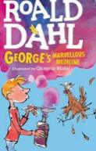   The danger gang | Mysteries of Harris Burdick Spring 1  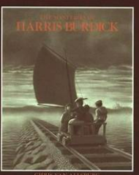 | Tilly & The time machine Summer 1  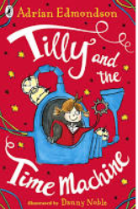 | Dragon Machine  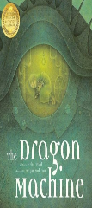  Autumn 1 | The First Drawing  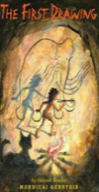  Autumn 2 |  | 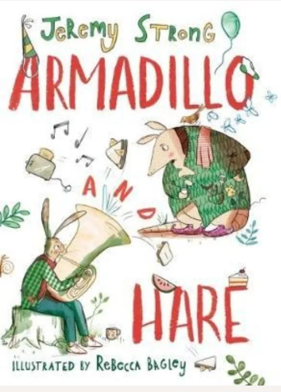  Armadillo and hare | Magic Finger  Spring 2b  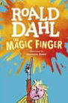 | Christmas Production variable | Beowulf  Summer 1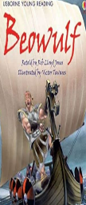 | Beowulf  Summer 1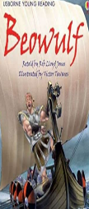 | The tunnel  Autumn1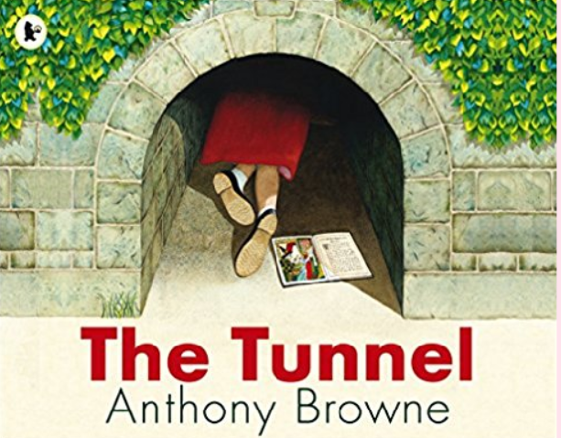 | Autumn 2  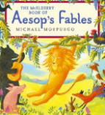  Aesop’s Fables | The wishing tree – Enid Blyton  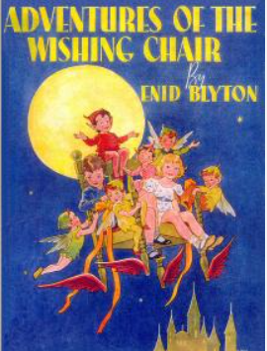 | The ride by nights  Spring 2a  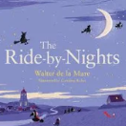 | Xmas production variable Autumn 2 | Lights on cotton rock  Spring 2  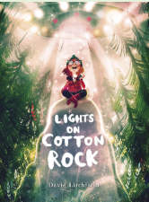 | Escape from Pompeii  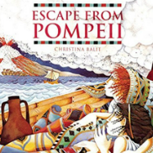 | Lost Species  Autumn 2  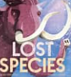 | The street beneath my feet Spring 1  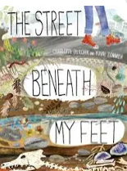 | Dear Earth  Summer 2  ;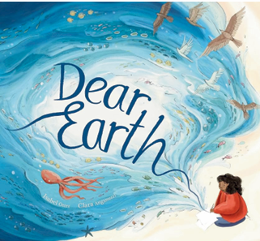 |   Dear Earth Summer 2
Class reads |  | Autumn 1:  Georges Marvellous Medicine, & a range of picture books |  |  | Autumn 2:  Aesop’s Fables, The wishing tree & Script |  |  |  | Spring 1:  Escape from Pompeii  Buzz sausage wolf |  |  |  |  | Spring 2:  Erika & the anger mare |  |  | Summer 1:  Armadillo and hare |  |  | Summer 2:  The danger gang
 | Adventure | Mystery | Sci-Fi | Fantasy | Historical Fiction |  | Contemporary Fiction | Dilemma | Play scripts | Myths | Legends | Fairy Tales | Fables | Traditional Tales | Poetry | Oracy | Instruction | Reports | Recounts | Explanation | Discussion | Persuasion
Year 4 | The Firework-Maker’s Daughter Summer 1 / 2  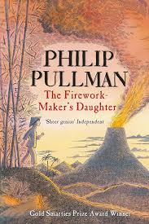  The Butterfly Lion Autumn 1  Autumn 2  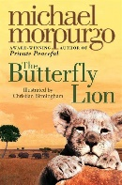  Island Spring 1  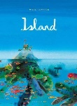  Stig of the Dump Spring 1  Spring 1 / 2  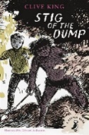  Journey spring 1  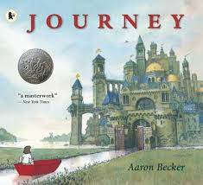  James and the Giant Peach Summer 2  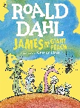 | Frankenstein Summer 1  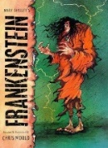 |  | Bubbles Autumn 1  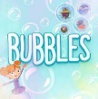  The Lion, the Witch and the Wardrobe Summer 1 / 2  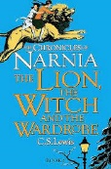  The BFG Summer 1 / 2  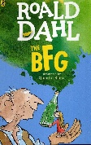 | History Hackers – Viking Voyage Autumn 1  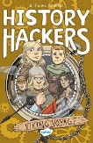  How to be a Viking Autumn 1  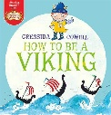  The Butterfly Lion Autumn 1  Autumn 2 |  | The Brilliant World of Tom gates  Autumn 1  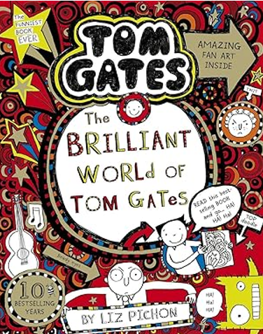 | Diary of a Killer Cat  Autumn 2  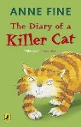 |  | Viking myths / legends Autumn 1 | The Pied Piper of Hamlin  Spring 2  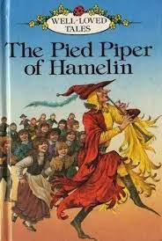  Viking myths / legends Autumn 1 | Jim and the Beanstalk Autumn 2  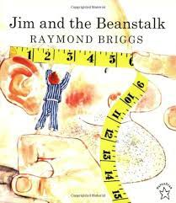 | Norman the caterpillar Autumn 1  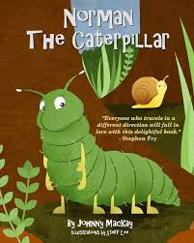 | The Gruffalo  Autumn 1  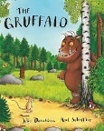 | The Gruffalo  Autumn 1  Rang Tang in my bedroom Autumn 2  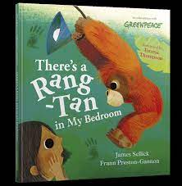  Cloud soup Spring 1  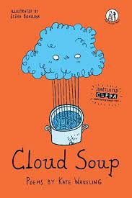 | Take one picture Spring 2  Northamptonshire shoe industry Spring 1 |  | Explorers (DK) Spring 2  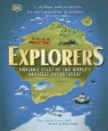  Famous Scientists – ongoing | Shackleton’s Journey Spring 2  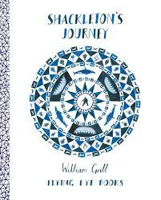  The Story of Tutankhamun Summer 1  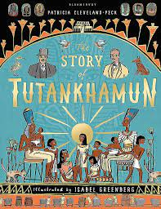  The Titanic Detective Agency Summer 2  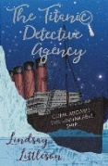  History Vikings -Autumn 1 / Ancient Egyptians Summer 1 | How does a lighthouse work? Autumn 2  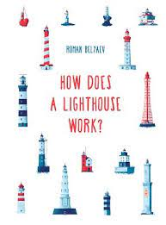  Rang Tang in my bedroom Autumn 2  River Story Summer 2 | Geography – rainforests Autumn 2  Take One Picture – Spring 2
Class reads |  | Autumn 1:  4JD The Brilliant World of Tom Gates  4VdB: History Hackers – Viking Voyage |  |  | Autumn 2:  4JD / 4VdB The Butterfly Lion |  |  |  | Spring 1:  4JD / 4VdB Stig of the Dump |  |  |  |  | Spring 2:  4JD / 4VdB Stig of the Dump |  |  | Summer 1:  4JD: The BFG  4VdB: The Firework-Maker’s Daughter |  |  | Summer 2:  4JD: The BFG  4VdB: The Firework-Maker’s Daughter
 | Adventure | Mystery | Sci-Fi | Fantasy | Historical Fiction |  | Contemporary Fiction | Dilemma | Play scripts | Myths | Legends | Fairy Tales | Fables | Traditional Tales | Poetry | Oracy | Instruction | Reports | Recounts | Explanation | Discussion | Persuasion
Year 5 | 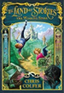  The land of stories Autumn 1  The Nowhere Emporium  Spring 2 and Summer 1  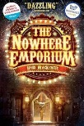 | Leon and the place between  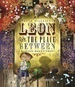  Autumn 1  The Great Chocoplot Spring 1    The Viewer Summer 2  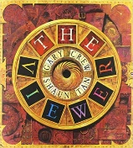 | Jamie Drake Autumn 2  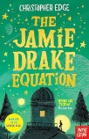 | The land of stories Autumn 1 | 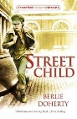  Street Child Autumn 1  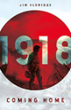  1918 Summer 1 |  | The Great Chocoplot Spring 1  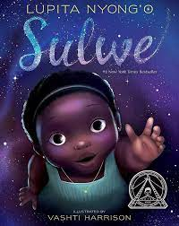  Sulwe Spring 1 | Jamie Drake Autumn 2  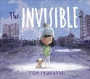  Invisible Spring 1  The Boy with Big Decisions Summer 1  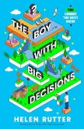  The Wrong Shoes Summer 2  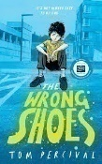 | The Tempest  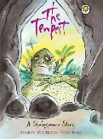 | Norse Folktales, Myths and legends Summer 2  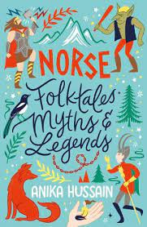 | Norse Folktales, Myths and legends Summer 2 | The land of stories Autumn 1  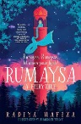  Rumaysa Spring 2 |  | 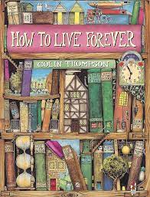  How to live forever Spring 2  Cloud Tea Monkeys Spring 2  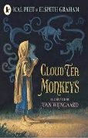 | 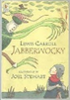  The Jabberwocky Autumn 1 | Spring 1 Northampton debate | The Promise  Summer 1  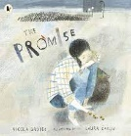 | Recycling  Summer 2  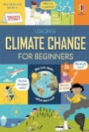 | Walter Tull Scrap book Summer 1  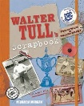 | 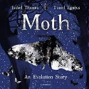  Moth Spring 2  Geography Spring 2 | Industrial Revolution Autumn 1  Northampton Spring 1 | The Wrong Shoes Summer 2  Geography Summer 2
 |  |  |  | The Nowhere Emporium  Spring 2 and Summer 1 |  |  |  |  |  |  |  |  |  |  |   Love that dog Autumn 2 | Summer 1 WW1 |  | Science Summer 1 | Science Spring 1 |  | Industrial Revolution Autumn 1  Northampton Spring 1
Class reads |  | Autumn 1:  Land of stories |  |  | Autumn 2:  Land of stories |  |  |  | Spring 1:  The Great Chocoplot |  |  |  |  | Spring 2:  The Nowhere Emporium |  |  | Summer 1:  The Nowhere Emporium |  |  | Summer 2:  The Wrong Shoes
Year 6 | Adventure | Mystery | Sci-Fi | Fantasy | Historical Fiction |  | Contemporary Fiction | Dilemma | Play scripts | Myths | Legends | Fairy Tales | Fables | Traditional Tales | Poetry |  | Instruction | Reports | Recounts | Explanation | Discussion | Persuasion
 | The Adventures of Odysseus  Autumn 2  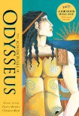  Children of the Benin Kingdom by Dinah Orji Spring 1  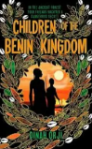 | The Old Mill by Pie Corbett  Autumn 1  Room 13 by Robert Swindell Autumn 2  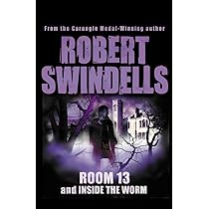 | Holes by Louis Sacher  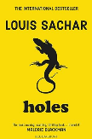  Summer 1 & 2 | Holes by Louis Sacher  Summer 1 & 2 | Blackout by Tony Bradman Autumn 1  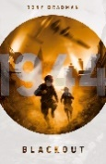  Children of the Benin Kingdom by Dinah Orji Spring 1 |  | Holes by Louis Sacher  Summer 1 & 2  The Island by Armin Greder  Spring 1  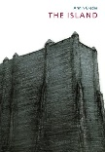 | The Island by Armin Greder  Spring 1 |  | The Adventures of Odysseus  Autumn 2 |  | Hansel and Gretel Autumn 1  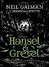 |  | The Jungle book – exerts by Rudyard Kipling Autumn 2  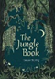 | Rain and Shine – Snippets Autumn 1  Flanders Field Autumn 2  Rain and shine – snippet Spring 1  Jack Frost – snippet Spring 1 |  |  | The Octopus – Snippets  Autumn 1 | The Great Plague – Snippets Autumn 1 | Range of non-fiction texts Autumn 2  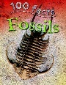
Class reads |  | Autumn 1:  HM/JM – Stuck in a story.  SM – The Boy in the Suit |  |  | Autumn 2:  HMJM – The Christmasaurus  SM – The Boy in the Suit |  |  |  | Spring 1:  HM/JM – Space Band  SM – Land of Stories 2 |  |  |  |  | Spring 2:  HM/JM – The Explorer  SM – Land of Stories 2 |  |  | Summer 1: |  |  | Summer 2:

Class text only
Reading sessions only
English
Wider curriculum

