

Park Junior: Reading Journey 2026-2027

KS1
Spelling | No specific stand-alone spelling lessons are done. Spellings mostly compose of the RWI red words. They are planning to look into this in the future.
Handwriting | They follow Kinetic letters still and Head said that they focus on letter formation and core body strength and two feet on the floor etc but don’t move onto the joining. They hope they set the children up ready with ‘snugging’ letters and the flicks.
English (Reading and writing) | They use ‘Talk for Writing’ which covers reading and writing. They do 5 pieces of writing a week – one adult focused. Three are writing in the morning first thing to a stimulus. They do hot and cold writes.  There is a daily morning phonics for 40 minutes and another session in the afternoon.  They have started using ‘Grammarsuarus’ ‘Place Value of punctuation and grammar’ (since January)  No set scheme for interventions.

Year group |  | Year 3 | Year 4 | Year 5 | Year 6
Term
Autumn 1 | Class text | 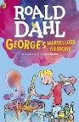  George’s Marvelous Medicine & a range of picture books    The tunnel  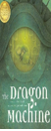  Dragon Machine (handwriting & SPAG focus)  Variety of picture books | 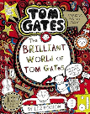  4JD Brilliant World of Tom Gates  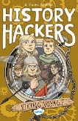  4VdB: History Hackers – Viking Voyage  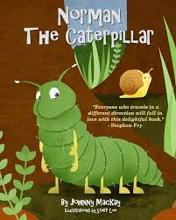  Norman the caterpillar  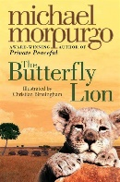  The Butterfly Lion  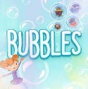  Bubbles (animation)  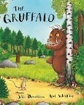  The Gruffalo  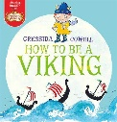  How to be a Viking | 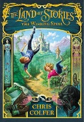  The Land of Stories Book 1  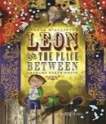  Leon and the place between  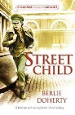  Street child  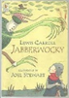  The Jabberwocky | 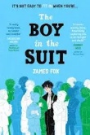  6SM The Boy in the Suit  by James Fox  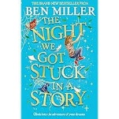  6HM/JM The night we got stuck in a story.  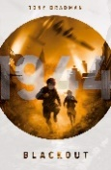  Blackout    The Old Mill by Pie Corbett  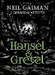  Hansel and Gretel by Neil Gaiman  Snippets  Poetry – Rain and Shine, Grannie  Non-Fiction –
Autumn 1 | Reading
Autumn 1 | English
Autumn 1 | Other
Autumn 2 | Class text | 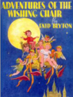  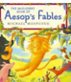  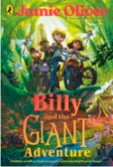  Aesop’s fables  Wishing chair  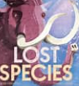  Lost species & weekly extract  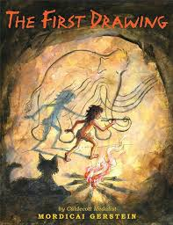  The First Drawing | 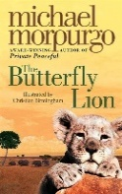  4JD / 4VdB The Butterfly Lion  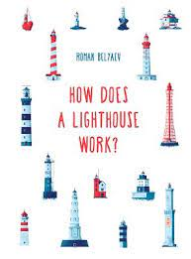  How does a lighthouse work?  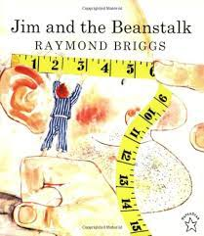  Jim and the Beanstalk  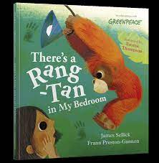  Rang Tang in my bedroom  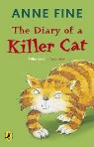  Diary of a Killer Cat | The Land of Stories Book 1  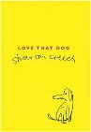  Love that dog  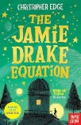  The Jamie Drake Equation  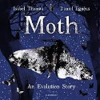  Moth | 6SM The Boy in the Suit  by James Fox  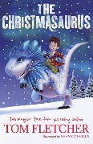  6HM/JM The Christmasaurus  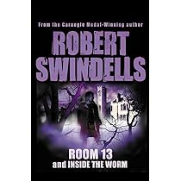  Room 13  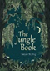  Exerts from The Jungle Book  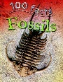  Non-Fiction Texts  Snippets  Poetry – Jungle Book  Archaic Poetry – Flanders Field  Non-Fiction – Bugs
Autumn 2 | Reading
Autumn 2 | English
Autumn 2 | Other
Spring 1 | Class text |   Buzz sausage wolf  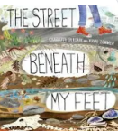  The street beneath my feet Spring 1  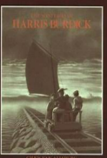  Mysteries of Harris Burdick  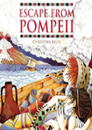  Escape from Pompeii | 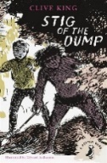  4JD / 4VdB Stig of the Dump  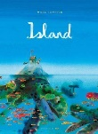  Island  Stig of the Dump  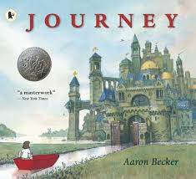  Journey  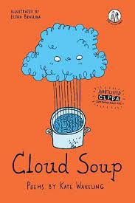  Cloud soup | 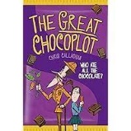  The Great Chocoplot  The Great Chocoplot  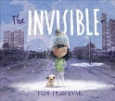  Invisible  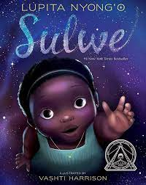  Sulwe  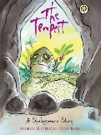  Shakespeare – The Tempest | 6SM Land of Stories 2  6HM/JM Space Band  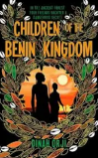  Children of the Benin kingdom  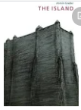  The Island  Snippets:  Archaic Poetry – Shakespeare (Julius Ceaser)  Non-fiction – Interviews  Historical Fiction – Private Peaceful
Spring 1 | Reading
Spring 1 | English
Spring 1 | Other
Spring 2 | Class text | 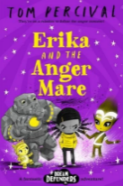  Erika & the Anger Mare  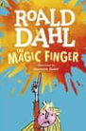  The magic finger & weekly extract  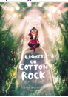  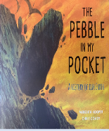  Lights on cotton rock  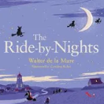  The ride by nights | 4JD / 4VdB Stig of the Dump  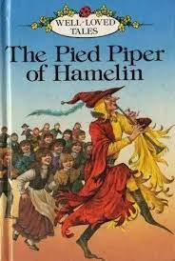  The Pied Piper of Hamlin  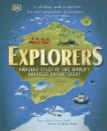  Explorers (DK)  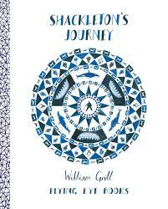  Shackleton’s Journey | 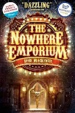  The Nowhere Emporium  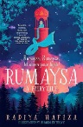  Rumaysa  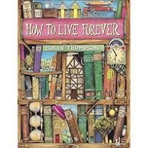  How to live forever  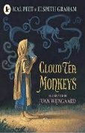  Cloud Tea Monkeys | 6SM – Land of Storie 2  6HM/JM – The Explorer  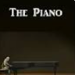  The Piano
Spring 2 | Reading
Spring 2 | English
Spring 2 | Other
Summer 1 | Class text | 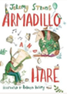  Armadillo and hare  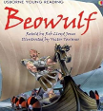  Beowulf  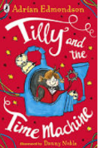  Tilly time machine | 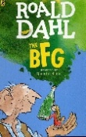  4JD: The BFG  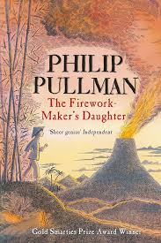  4VdB: The Firework-Maker’s Daughter  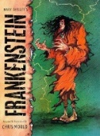  Frankenstein  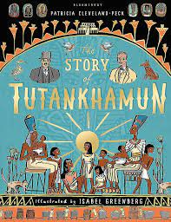  The Story of Tutankhamun  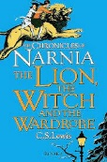  The Lion, the Witch and the Wardrobe | The Nowhere Emporium  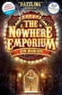  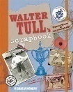  Walter Tull Scrap book  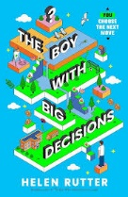  The Boy with Big Decisions  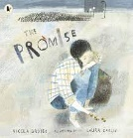  The Promise  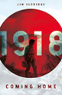  1918 | 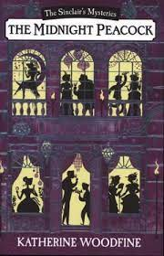  The Midnight Peacock  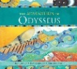  The Adventures of Odysseus  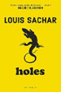  Holes  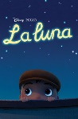  La Luna
Summer 1 | Reading
Summer 1 | English
Summer 1 | Other
Summer 2 | Class text | 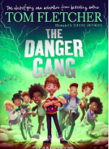  The danger gang  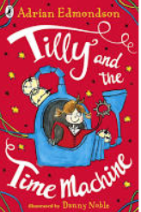  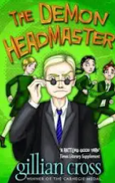  Tilly & the time machine  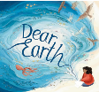  Dear Earth | 4JD: The BFG  4VdB: The Firework-Maker’s Daughter  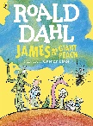  James and the Giant Peach  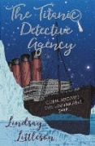  The Titanic Detective Agency  The Lion, the Witch and the Wardrobe  Gorillas – non chronological report | 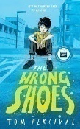  The Wrong Shoes  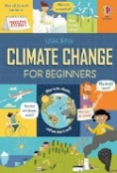  Climate Change for beginners  The Wrong Shoes  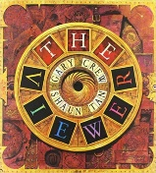  The Viewer  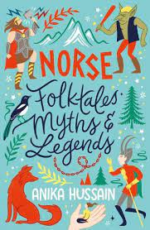  Norse Folktales, Myths and Legends | 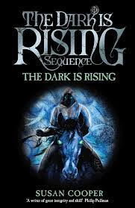  The Dark is Rising  Holes
Summer 2 | Reading
Summer 2 | English
Summer 2 | Other

