Environmental Change– Knowledge Organiser Year 4 Summer 2
VOCABULARY |  | Human Impact on the Environment |  | The Greenhouse Effect and Climate Change
adapt | change so that a plant or animal is better suited to survive in its habitat. | Positive  - Recycling  - Animal protection  - Habitat conservation  - Marine parks/ nature reserves  - Growing own food  - Improving local habitats e.g., bird houses, ponds, tree planting | Negative  - Pollution (land, air, water)  - Deforestation  - Over-fishing  - Urbanisation  - Hunting and trade in endangered species  - Intensive farming  - Over-population  - Litter and waste | A protective layer of gases called the atmosphere surrounds the Earth. Heat energy from the Sun passes through the atmosphere and warms up the Earth’s surface.  Greenhouse gases from pollution create an invisible ‘blanket’ high up in the atmosphere, which stops a lot of the heat energy from reflecting back out into space. This trapped heat warms up the atmosphere and is changing our weather patterns, leading to rising temperatures and extremes of weather - both of which are damaging our natural environment. This is called Climate Change.  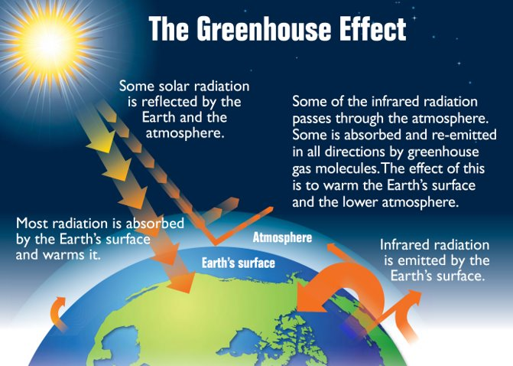
migrate | move to a new habitat or location to find food or escape drought.
hibernate | sleep through the winter to save energy.
Climate Change | a change in global climate patterns, largely due to an increase in carbon dioxide from burning fossil fuels.
The Greenhouse Effect | the effect seen when gases such as carbon dioxide collect and form an invisible ‘blanket’ around the atmosphere which causes the world to heat up.
atmosphere | The layer of gas (air) that surrounds the Earth.
ecosystem | a community of living things together with their environment. | Deforestation and Tropical Rainforests
deforestation | the action of cutting down large areas of trees to build houses, harvest timber, grow crops etc. | Deforestation is the destruction of forests to provide land for homes, crops and transport or to harvest trees for timber. Deforestation of rainforests is particularly harmful as it causes wide-scale soil erosion, loss of habitat for endangered wildlife and the loss of homes to many people. Tropical rainforests support a huge biodiversity (although they only cover about 3% of the Earth’s surface, they contain over half of the world’s plant and animal species) and they act as the world’s ‘lungs’ – providing much of the oxygen essential to life and removing a considerable amount of harmful carbon dioxide from the atmosphere.
urbanisation | the process by which a town or city grows as more people move there.
extinct | no longer exists.
endangered | a plant or animal at risk of becoming extinct.
conservation | the protection of endangered species or habitats.
biodiversity | the variety of living things found in a particular habitat or ecosystem.

