Commitments – Knowledge Organiser Year 4 Summer 2
VOCABULARY |  | 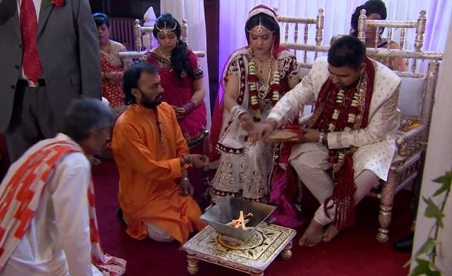        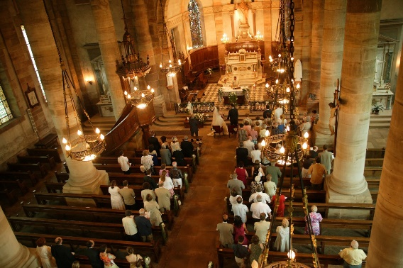
Promise | If you promise that you will do something, you say to someone that you will definitely do it.
Commitment | A strong belief in an idea or system. Something which regularly takes up some of your time because of an agreement you have made or because of responsibilities that you have. If you make a commitment to do something, you promise that you will do it.
Milestone | An important event in the history or development of something or someone.
Dedication | Complete and wholehearted devotion, especially to a career, ideal.
Entry | If you gain entry to a particular place, you are able to go in. Someone's entry into a particular group is their joining of it.
Sacred | Something connected with religion or used in religious ceremonies is described as sacred.
Ceremony | A formal event.
Vows | A particular set of serious promises, such as the promises two people make when they are getting married.
Marriage | Two people making an official commitment to each other.
Wedding | A wedding is a marriage ceremony.
Duty | A task or action that a person is bound to perform for moral or legal reasons.

