From Nene to the Nile – Knowledge Organiser Year 4 Summer 2
Vocabulary |  | The River Nile  6,695km – The longest river in the world.  Flows through 11 African countries.  Has two main tributaries which meet to form the Nile. One is the White Nile, which begins in South Sudan, and the other is the Blue Nile, which starts in Ethiopia.  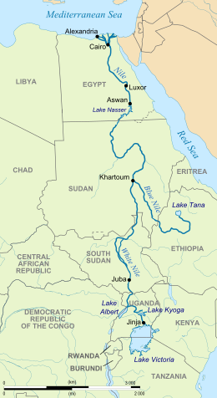  The River Nene  161km – The tenth longest river in the UK  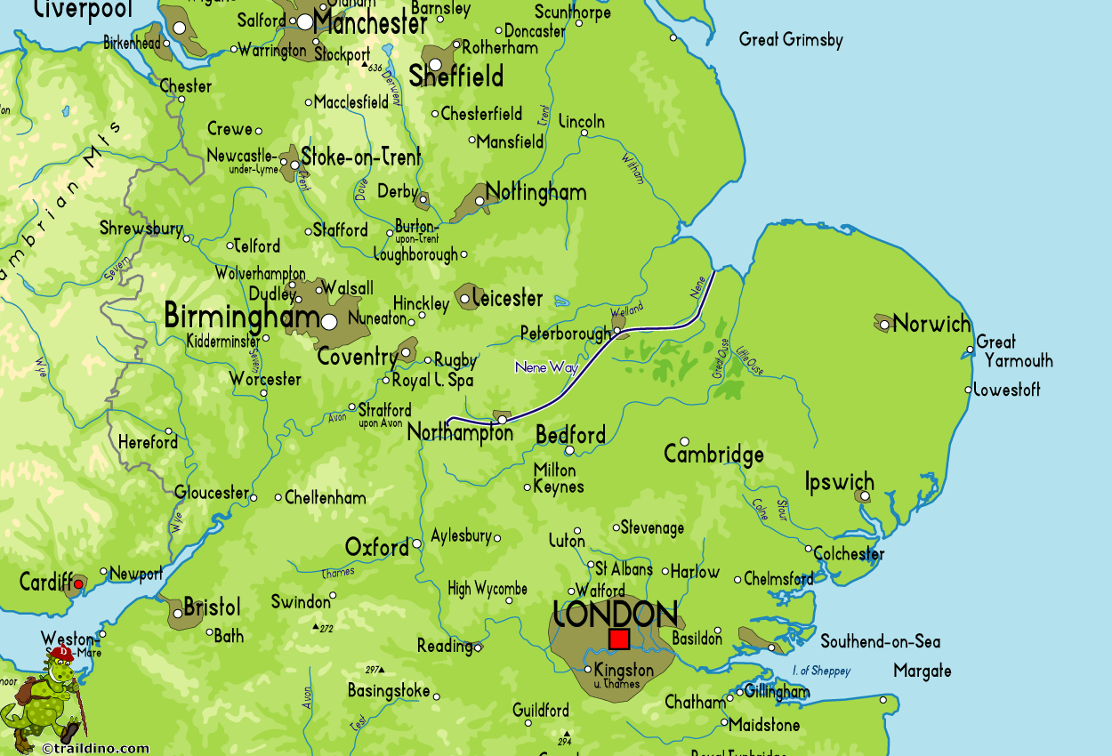 | The Journey of a River
source | The original point where a river begins. |  | 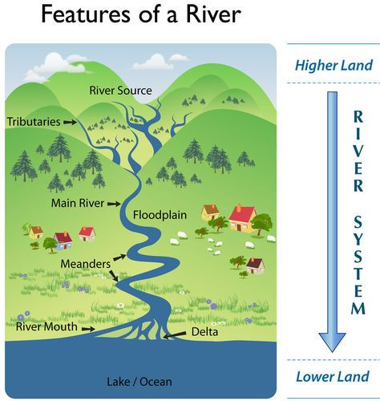  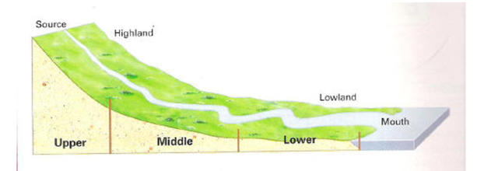
  Physical Geography | The part of geography that deals with natural features.
  Human Geography | The part of geography that deals with the study of people, communities and cultures, and their interaction with their environment.
tributaries | A small river or stream that flows into a larger river or lake.
riverbank | The land that makes up the side of a river; usually made from rock or soil.
riverbed | The bed or channel in which a river flows.
mouth | The part of a river that joins a sea or ocean.
erode | When parts of land such as soil or rocks are worn away by a flowing body of water.
meander | The winding course of a river.
estuary | The tidal mouth of a river; where the river meets the tide of a sea or ocean.
fertile | Land or soil that can produce lots of vegetation or crops.
irrigate | To supply water to land or crops to help growth.
runoff | Rain that does not get absorbed into the soil.
bankfull | When the water level is at the top of the river banks.

