Why is Pentecost important to Christians? – Knowledge Organiser Year 4 Summer 1

VOCABULARY |  | 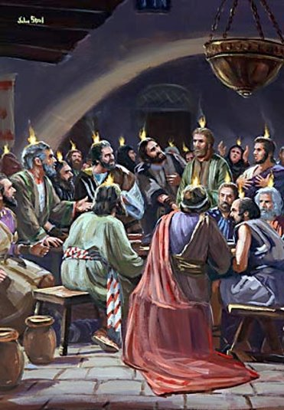  The Disciples being visited by the  Holy Spirit  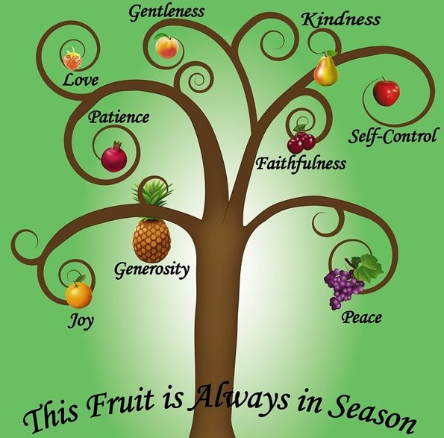  The Fruits of the Spirit
Easter | The celebration of the death and resurrection of Jesus.
Ascension | Jesus moving from Earth to Heaven, 40 days after Easter Sunday.
Pentecost | A Christian festival celebrated 50 days after Easter Sunday.
Disciple | A dedicated follower of Jesus.
Holy Spirit | A third of the Trinity. The Holy Spirit does the will of the Father (God) and the Son (Jesus).
Faithfulness | To be faithful is to be reliable or trustworthy.
Fruits of the Spirit | Love, joy, peace, patience, kindness, generosity, faithfulness, gentleness, self-control

