Ancient Egyptians – Knowledge Organiser Year 4 Summer 1
Vocabulary |  | 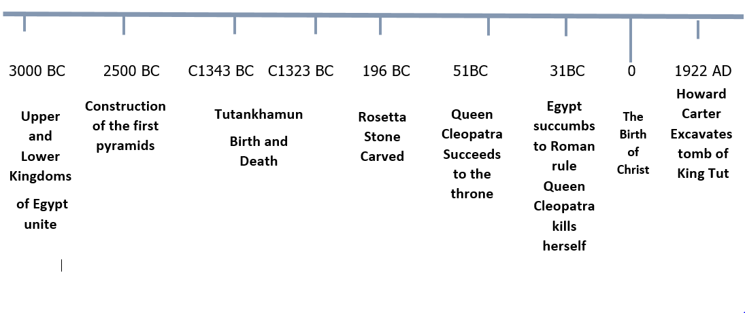
ancient | Belonging to the distant past, in particular to the period in history before the end of the Roman Empire.
River Nile | The longest river in Africa. North flowing through Egypt into the Mediterranean Sea.
civilization | A fully developed society and culture.
  Important People |  | Map of Egypt
  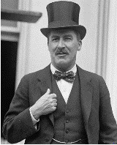  Howard Carter | An English archaeologist who discovered the tomb of King Tutankhamun in 1922. | 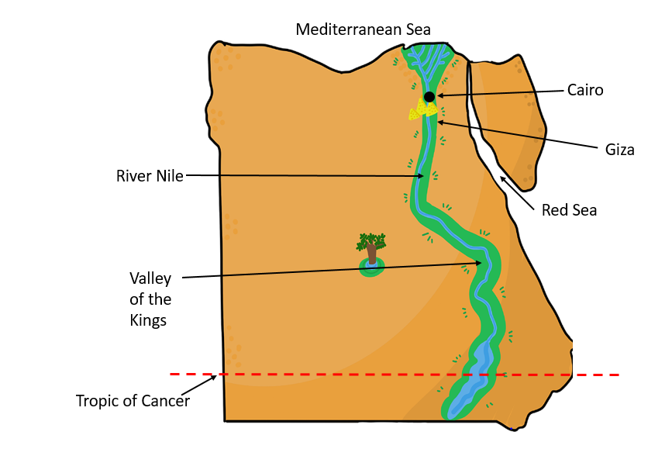
  Tutankhamun  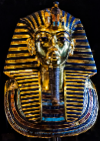 | An Egyptian King (also known as a pharoaoh), who took the throne when he was 8 or 9 years of age and sadly died when he was around 18.
kingdom | A country or state ruled by a king or queen.
hieroglyph | A symbol of an object representing a word, syllable, or sound
papyrus | Material prepared from the stem of a water plant, formed into sheets of paper for writing.
cartouche | An oval frame around a design or inscription, often representing a monarch
pyramid | A monumental structure with a square or triangular base with sloping sides that meet in a point. Especially built of stone as a tomb.
pharaoh | The name for an ancient Egyptian ruler.
tomb | A large vault, typically underground, for burying the dead.
mummy | A body of a human being or animal that has been preserved with special treatment and wrapped in bandages.
excavation | remove earth carefully from an area in order to find buried remains.

