Science – Knowledge Organiser Year 4 Spring 2
Vocabulary |  | How are sounds made?  Sounds are made when objects vibrate.  The vibrations create sound waves.  Sounds travel through different mediums. They travel better though solids than liquids. They travel through liquids better than air.  In a vacuum, there is no matter (solid, liquid or gas) so sounds cannot be heard.  How do we hear a sound?  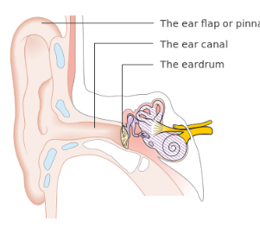  Message to the brain  Sound vibrations  The ear ‘catches’ the sound vibrations.  They hit the eardrum, making it vibrate.  This sends a message to the brain. | Pitch    Low pitch  Low pitch sounds are made from slower vibrations.  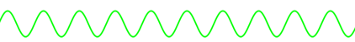  High pitch  High pitch sounds are made from faster vibrations.  Volume  Sound can be loud or quiet depending on how much energy is used to make it. Hitting a drum hard uses more energy so will make a loud sound.  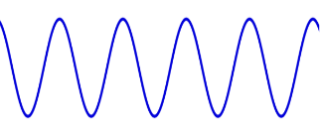  Loud  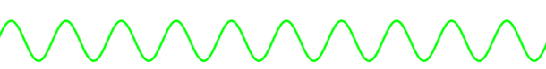  Quiet  The closer you are to the source of a sound, the louder it will seem.
sound | type of energy made by vibrations
vibrate | to move quickly to and fro
vibration | the action of something vibrating
source | starting point (of a sound, for instance)
medium | any matter (solid, liquid or gas) that allows sound waves to pass through
vacuum | a space with no matter (solid, liquid or gas)
muffle | to quieten a sound (for instance, by wrapping it in something)
soundwave | the shape of the movement of sound through a medium
volume | measure of loudness
pitch | how high or low a sound is
sound insulator | a material that reduces the amount of sound passing through it

