Year 4 Knowledge Organiser Spring 2 Easter: Why is Holy Week important to Christians?
VOCABULARY |  | 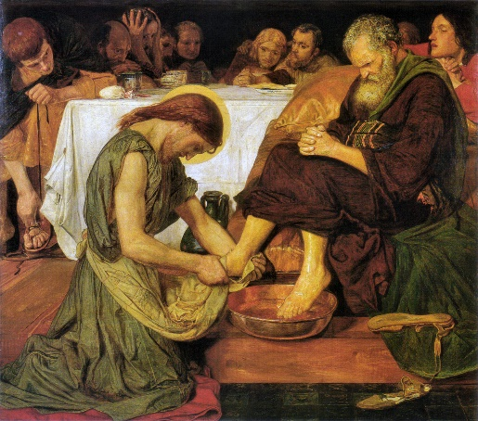  Jesus described himself as the servant king and washed his disciples’ feet. He encouraged his disciples to behave in the same way.    The crowds waved palm leaves to welcome Jesus and laid them on the floor.  The events of Holy Week:  - Palm Sunday – The Journey into Jerusalem  - Judas betrays Jesus  - Maundy Thursday – The Last Supper and praying at Gethsemane. Betrayal and arrest.  - Peter’s denial  - Good Friday – the trial of Jesus and his Crucifixion  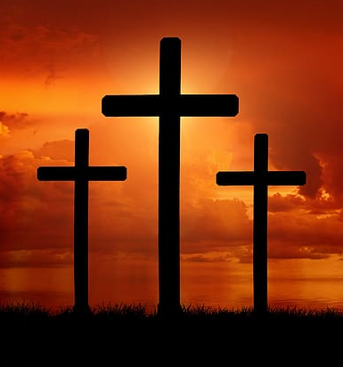  - Easter Sunday – the empty tomb
Holy Week | The events of the seven days before Easter Sunday.
Palm Sunday | The day Jesus travelled into Jerusalem on a donkey. People waved palms to welcome him.
Maundy Thursday | The day of The Last Supper.
Good Friday | The day Jesus was crucified (nailed to the cross).
Easter Sunday | The day Jesus was resurrected.
Resurrection | To be brought back to life after someone has died. Christians believe Jesus came back to Earth after his crucifixion.
Betrayal | Breaking somebody’s trust.
Denial | A refusal to admit the truth.
Disown | To reject someone.
Religious council | A group of religious leaders who were appointed to make laws or give advice.
Innocent | Not guilty
Pontius Pilate | The Roman Governor at the time of Jesus’s crucifixion.

