Electricity – Knowledge Organiser Year 4 Spring One
VOCABULARY |  | Components of an electric circuit  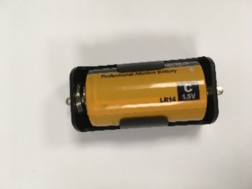  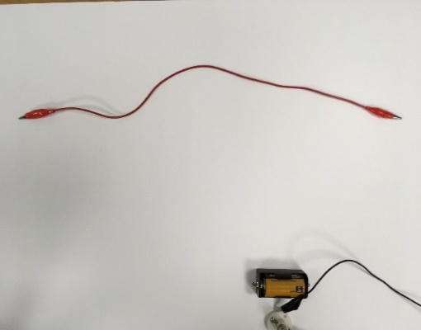  cell  wire  buzzer  lamp  switch  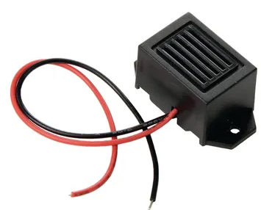  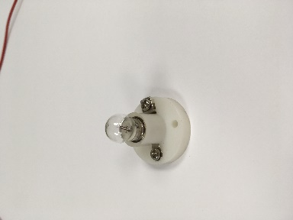  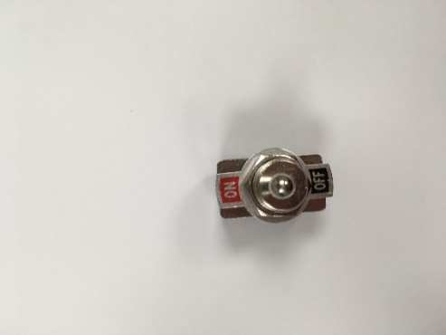  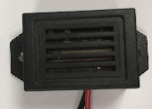  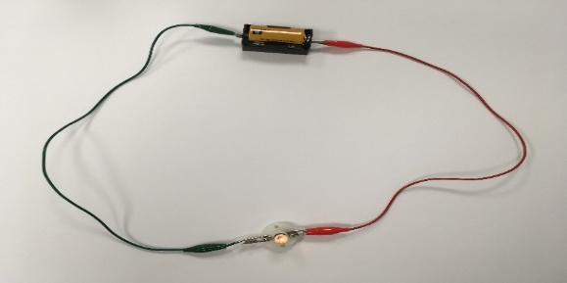  A complete circuit | Electrical conductors  Many metals (for example copper, iron and steel) are good conductors of electricity.  A plug uses metal to allow electricity to transfer from the plug to the device.  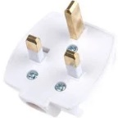  Electrical insulators  Paper, rubber, wood and plastic are examples of good insulators. The plastic coating on wires protects people from getting an electrical shock.  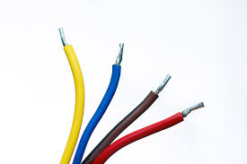
electricity | A type of energy. It can be used to power appliances.
appliance | A device, often electrical, that does a particular job.
mains electricity | Electricity that comes from a power station and is sent to homes and other places.
components | The parts of an electric circuit - for example, bulb, wire, buzzer.
circuit | The path around which electricity flows.
complete circuit | A circuit with no gaps (the opposite is an incomplete circuit).
current | Scientific word for the flow of electricity.
cell | Component that changes chemical energy into electrical energy.
battery | One or more cells working together. |  | Hazards  - Overloading a plug socket  - Exposed wires  - Damaged wall sockets  - Wires left out to trip over  - Placing metal objects into electrical appliances or sockets  - Electrical appliances or wires near water
electrical conductor | Material that allows electricity to flow through it.
electrical insulator | Material that does not allow electricity to flow through it.
switch | Opens and closes a gap in a circuit to turn an appliance on and off.
hazard | A danger or risk.

