Year 4 Knowledge Organiser spring 1 Hinduism Part 2: What does it mean to live as a Hindu?
VOCABULARY |  | 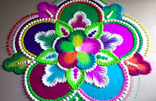  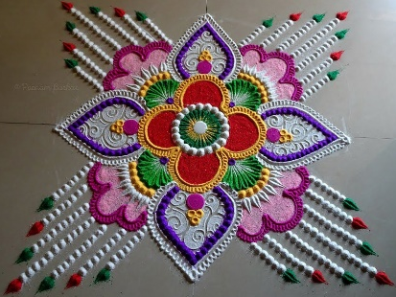  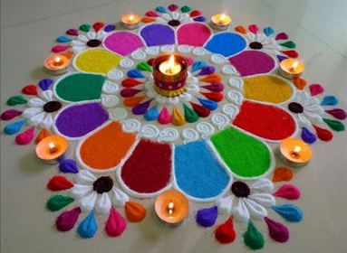  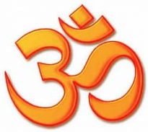  Aum – a special sign for God, often seen in Hindu homes and places of worship.  Rangoli patterns
Hinduism | One of the world’s oldest religions – more than 4,000 years old.
Hindu | Followers of the religion of Hinduism. Many Hindus live in India and other Asian countries, like Nepal and Indonesia. But there are also a lot of Hindus who live in Europe, North America and Africa.
Brahman | The one God in Hinduism.
Murti | A sacred image/statue of a deity or person in Indian culture.
Trimurti | Three main Hindu deities – Brahma, Vishnu, and Shiva
Mandir | An Indian word for temple, where many Hindus worship.
Shrine | A place that has a holy statue or image of a Hindu deity which is used for prayer.
Vedas | A religious text.
Puja | The main Hindu form of worship. It means ‘giving respect’.
Mantra | Chanting during prayer to summon the deity's attention.
Prasad/  Prashad | Blessed food which is eaten once worship has finished.
Reincarnation | The Hindu belief that when they die they leave their body and enter another.  Hindus believe that they pass through many lives as a human, animal or plant. Hindus believe this goes on until they are reunited with Brahma.
Dharma | A sacred code of behaviour. A person's duty to do the right thing in any situation
Karma | The law of cause or effect. Every action we take will have consequences – positive and negative.
Moksha | The freeing of the soul from the cycle of death and rebirth when the soul reunites with the God Brahma.
Samsara | The cycle of birth, life, death and reincarnation
Duties | Tasks to be done that are your responsibility.
Rangoli | In Hindu tradition, Rangoli is a colourful design made on the floor near the entrance of a house. It is traditionally created using coloured rice powder.

