Why are Diwali and Christmas important festivals? - Year 4 Autumn 2
celebration | A celebration is a special enjoyable event that is organised by people because something pleasant has happened. | 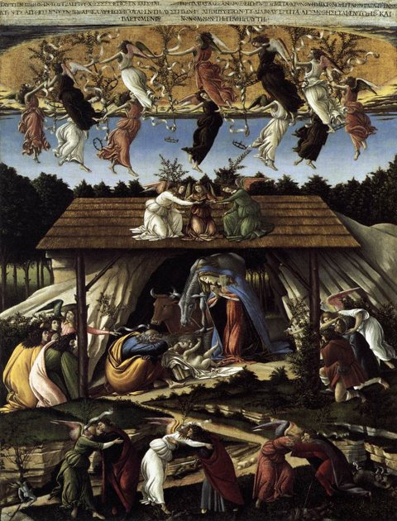  The Mystical Nativity by Sandro Botticelli
festival | A festival is a day or time of year when people celebrate a special event.
Goddess, God or Deity | In a religion a spirit who is believed to have a power over a particular part of the world or nature is called a Goddess, God or Deity.
Messiah | For Christians, the Messiah is Jesus Christ.
Nativity | The Nativity is the story of birth of Jesus which is celebrated by Christians at Christmas.
Hindu | A Hindu is a person who believes in Hinduism and follows its teachings.
Diwali | The Hindu festival of light.  

