Why is the rainforest important to me? – Knowledge Organiser Year 4 Autumn 2
Layers of the Rainforest |  | Benefits of the rainforest
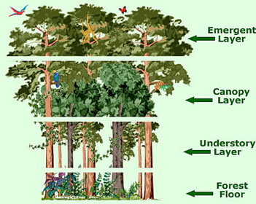 |  | - Plants release oxygen which helps to stabilise the Earth’s climate and protect the ozone layer.  - Rainforests maintain the world’s water cycle. | - 25% of modern medicines come from plants found in rainforests.  - Rainforests provide a home for over 30 million species of plants and animals. | - Rainforests provide many foods such as nuts, bananas, coffee and spices.  - Materials such as rubber, wood, resins, and oil can be found in rainforests.
Vocabulary |  | Map showing the location of the rainforests of the world.  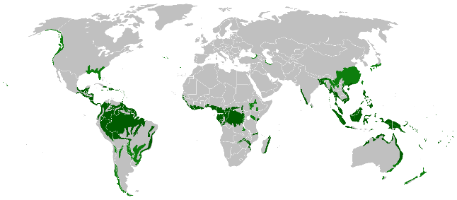 |  | South America
Rainforest | A dense forest, normally found in tropical areas with high rainfall. They generate much of the world’s oxygen. |  |  | 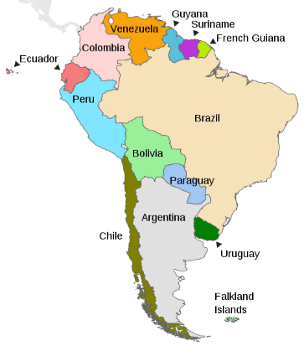  Key Mountain Range:  Andes (Spans 7 countries)  Kay Waterfall:  Angel Falls (Venezuela)  Key Rainforest:  Amazon (Spans 9 countries)  Key River:  Amazon river – 6,400km long (the second longest in the world)
Ozone Layer | The ozone layer is an invisible layer of protective gases that circle the earth.
Economy | The system of how money is made and used within a particular country or region.
tropics | The tropics are the parts of the world that lie between two lines of latitude, the Tropic of Cancer and the Tropic of Capricorn. | Deforestation
tropics |  | Causes | Impact
habitat | The natural home or environment of an animal or plant. | - To clear space for farming: growing crops (e.g. soya beans and palm oil) and space for cattle to produce beef.  - Chopping down trees for wood  - To build roads to mine for metals, gold and diamonds  - To flood areas to make dams and produce electricity. | - 28,000 species of animals are expected to become extinct in the next 25 years.  - Local people’s homes are being destroyed.  - Levels of carbon dioxide in the air are increasing and oxygen is decreasing.  - An area the size of 20 football pitches is destroyed every 60 seconds.  - Half of the tropical rainforests have gone.
deforestation | The action of clearing a wide area of trees.
Equator | An imaginary line through the middle of the Earth which receives the most sunlight.
Environment | The natural world or a particular geographical area, especially as affected by human activity.
Tropical | Something of the tropics or typical of the tropics.
indigenous | Originating from or happening naturally in a place.
Trade | Trade is the action of buying and selling goods and services.

