STATES OF MATTER – Knowledge Organiser Year 4 Autumn 1
Vocabulary |  | 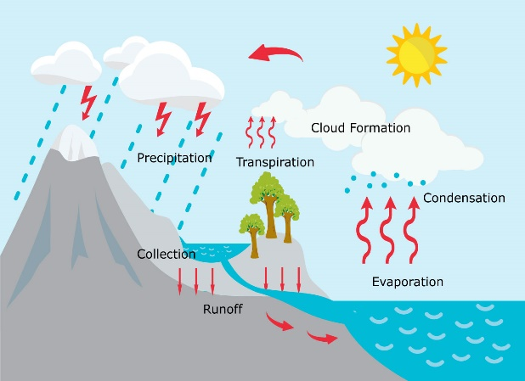  The water cycle is the continuous journey of water from the land to the sky and back to the land again. This constant movement of water is happening all the time and is vital to supporting life on earth.  There are four main stages in the water cycle:  Evaporation happens when warmth from the sun causes water (liquid) from the sea, lakes and rivers to rise into the air and turn to vapour (gas).  Condensation happens when the water vapour cools and turns back into drops of water which form clouds in the sky.  Precipitation is when the clouds get too heavy and water falls from the clouds in the form of rain, snow, sleet or hail.  Run off happens when the majority of this water runs over the land and flows back into lakes and rivers or gets carried back to the sea.  The Water Cycle | Properties
materials | The substances from which  all objects are made. |  | Solids, liquids and gases are called the states of matter. The properties of these states are different and can be used to help identify whether a material is a solid, a liquid or a gas.  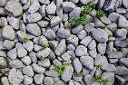  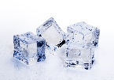    Solid  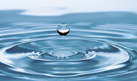
  Property | State of Matter
  Property | Solid | Liquid | Gas
  Shape | Fixed | No fixed shape | No fixed shape
  Volume | Fixed | Fixed | No fixed volume
  Ability to squash/  compress | Can’t be compressed | Can’t be compressed | Can be compressed
  Ability to pour and flow | Can’t be poured and it doesn’t flow | Can be poured and it does flow | Can be poured and it does flow
object | A single thing that can be seen or felt.
matter | The ‘stuff’ that everything in the  Universe is made from.
property | The appearance, characteristics  and behaviour of a material.
volume | The amount of space an object takes up.
compress | To reduce in size, quantity or volume by pressure.
process | A series of actions or steps.
heating | Increasing the temperature.
cooling | Decreasing the temperature.
melting | The change of state from solid to liquid.
freezing / solidification | The change of state from liquid to solid.
melting point | The temperature at which a solid changes to a liquid.
freezing point | The temperature at which a liquid changes to a solid.
temperature | A measurement of how hot or cold something is.
thermometer | An instrument used to measure temperature. |  | 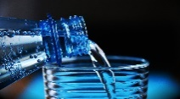    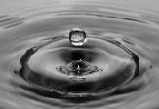  Liquid
evaporation | The change of state from liquid to  gas. | 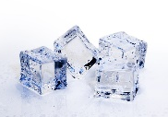    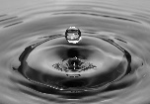  Gas  Liquid  Melting  Evaporation  Solid  Condensation  Solidification
condensation | The change of state from gas to  liquid. |  | 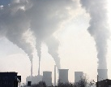  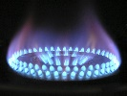    c  Gas
precipitation | When water falls from the clouds as  rain, snow, sleet or hail.

