The Vikings – Knowledge Organiser Year 4 Autumn 1
Vocabulary Timeline
Norsemen | Another name for a Viking. | 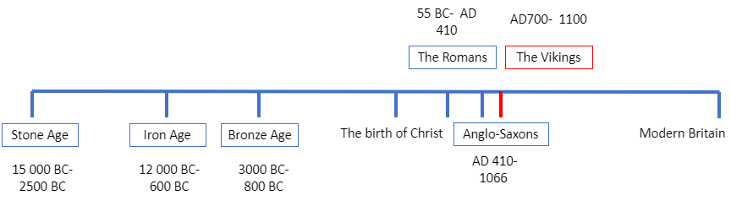
Raid | When soldiers raid a place, they make a surprise attack.
Monastery | The building where monks live.
Trade | The activity of buying, selling, or exchanging goods or services between people or countries.
Merchant | A person who buys or sells goods in large quantities.
Hearth | The floor of a fireplace.
Longhouse | A long, narrow, single room building where many families live together. | 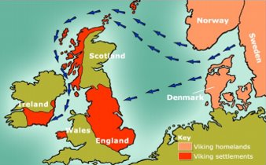  Viking homelands and settlements | Key Dates
Descendant | A person who is related to you and who lives after you, such as your child or grandchild |  | AD700 | The Viking age begins.
Descendant |  |  | AD793 | First attack on England at a monastery on Lindisfarne.
Hoard | Is an archeological term for a collection of valuable objects or artefacts, sometimes purposely buried in the ground. |  | 860 | Vikings attack Constantinople in Turkey.
Hoard |  |  | 866 | Large Viking force lands in England looking for land to settle on.
Iconography | The use of images and symbols to represent ideas and ways of life. | Who were the Vikings?  The Vikings, or Norsemen as they were often called, lived over 1000 years ago. They were Scandinvian people who lived in the countries we now call, Norway, Sweden and Denmark. Between the 8th and 11th century, the Vikings raided, explored and settled in new lands. | 867 | Vikings capture York and rebuild it as Jorvik.
 |  |  | 1066 | The English King Harold is killed at the battle of Hastings. The leader of the Normans, William the Conqueror, becomes the King of England.
 |  |  | 1100 | End of the Viking age. Viking settlers become part of the local population.

