Knowledge Organiser – Year 4 – Autumn 1

How are promises explained in the Old Testament and where do we see them in Christianity today?
Vocabulary |  | 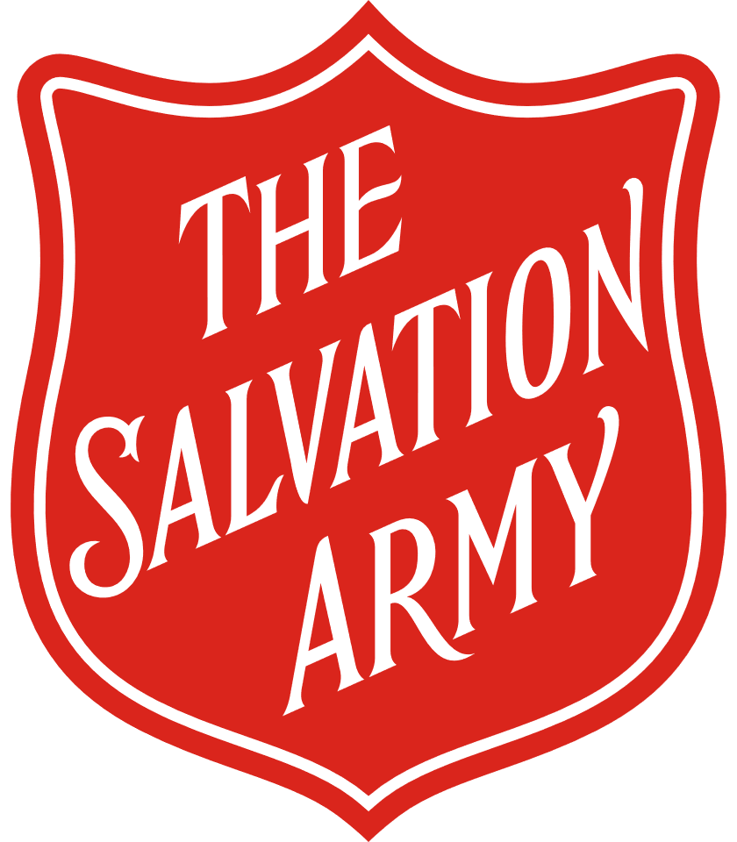  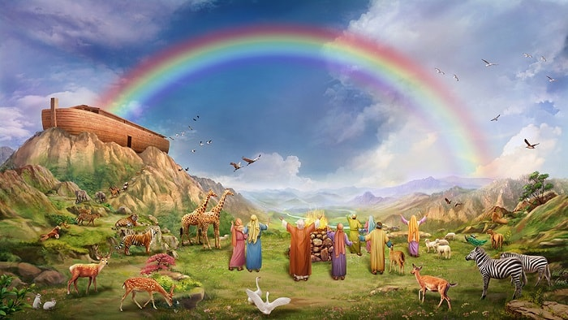  
Old Testament | The first part of the Bible, believed to be the sacred word of God.
New Testament | The second part of the Bible, which records the life and teachings of Jesus.
Ark | The ship built by Noah to save his family and two of every kind of animal from the Flood; Noah's Ark.
Covenant | A promise.
Noah | Chosen by God, he, his family, two of every animal were saved from the Flood.
Empathy | The ability to understand and share the feelings of another.
Consent | Giving permission.
Marriage  Vows | One of a set of promises made by two people when they get married.
Salvation | The act of being saved from harm, ruin, or loss.
Vulnerable | Exposed to the possibility of being attacked or harmed, either physically or emotionally.

