Year 3 Summer 2 Flowers and Life Cycles – Knowledge Organiser
VOCABULARY |  | Parts of a flower  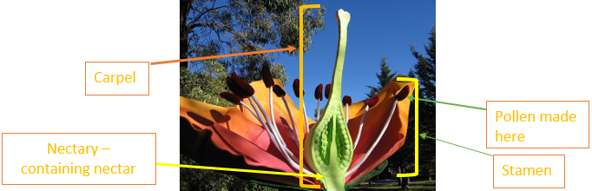  Pollination by bees  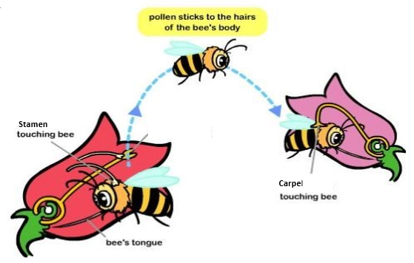 | Types of Seed Dispersal
nectar | A sweet liquid produced by flowers, which provides food for bees and butterflies.
  Wind | 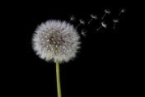
  Shaking | 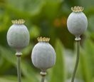
  Explosion | 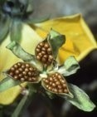
  Water | 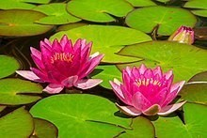
  Animals – carrying | 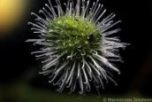
  Animals – eating | 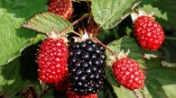
pollen | A fine powder produced by flowers which is needed to help plants make new seeds.
carpel | The part of the flower where seeds are formed.
stamen | The part of a flower that produces pollen.
scent | A pleasant smell, usually to attract someone or something.
reproduction | When living things produce babies which are similar to the parents.
pollination | The movement of pollen from stamen to carpel.
fruit | The part of a flowering plant that contains seeds.
dispersal | The spreading of things over a wide area.
ripe | A word to describe when fruit or grain is ready to be harvested or eaten.
seed | The part of a flower that can develop into a new plant.
variable | Something that can be changed in an experiment.
life cycle | The stages in the growth of a living thing from birth to death.

