SACRED BOOKS – Knowledge Organiser Year 3 Summer 2
VOCABULARY |  | Religions we will explore:
 |  | CHRISTIANITY | ISLAM | JUDAISM
 |  | Symbol:    Followers: Christians  Sacred book: The Bible  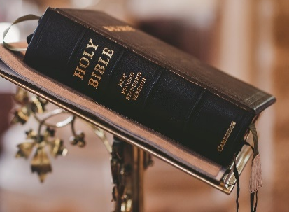  - The Bible is divided into two major parts: The Old Testament and the New Testament.  - The Bible teaches Christians about God, safety, love, life, family and so on.  - Christians use it to make sense of life and can turn to Jesus’s teachings for moral guidance. | Symbol:    Followers: Muslims  Sacred book: The Qur’an  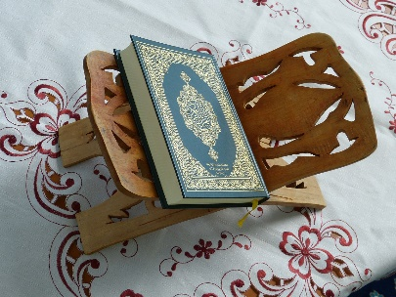  - The Qur’an is written in Arabic which Muslims believe to be the actual words of Allah (God).  - In the Qur’an, Muslims are told how to worship Allah and how they should behave towards each other.  - It is a highly respected book. Muslims must store the Qur’an in particular ways and show special behaviour when they are reading from it. | Symbol:    Followers: Jews/Jewish  Sacred book: The Torah  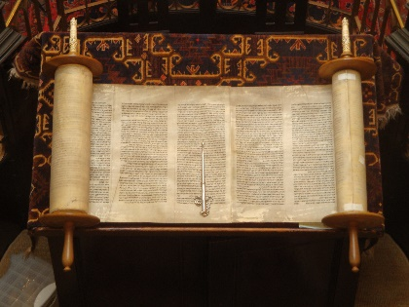  - ‘The Torah’ is the first part of the Jewish Bible, which contains five books of Moses.  - These sacred scriptures are written on a scroll and kept in a synagogue.  - The Torah’s main purpose is to help Jews answer the question ‘what does God require?’ Jews believe that the Torah shows them how God wants them to live.
sacred | Something that is sacred is believed to be holy and to have a special connection with God.
scripture | Scripture or the scriptures refers to writings that are regarded as holy in a particular religion.
authority | Sources of authority are places or people you go to when in need of guidance of help.
morality | Morality is the belief that some behaviour is right and acceptable, and that other behaviour is wrong.
parable | A parable is a short story, which is told in order to make a moral or religious point, like those in the Bible.
respect | If you respect someone or something, you think very highly of them/it. If you show respect for an object, you treat it well and carefully.
dictate | If you dictate something, you say or read it aloud for someone else to write down.
prophet | A prophet is a person who is believed to be chosen by God to say the things that God wants to tell people.
revelation | In religion, revelation is a sign or explanation from God.
omnipotent | Someone or something that is omnipotent has complete power over things or people.
omniscient | Someone who is omniscient is all-knowing, they know everything.

