Knowledge Organiser Year 3 Summer 2 Why should we recycle resources?
Vocabulary |  | 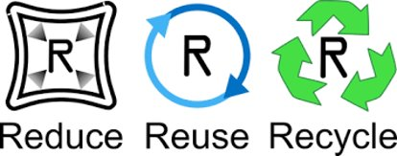 | Facts about Recycling
reduce | to use less; to use fewer resources |  | 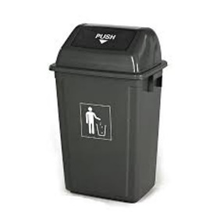  - Around 14 million glass bottles and jars are sent to landfill in the UK every day.  - Paper and card make up 40% of the waste collected for recycling from UK households.  - Recycling just one plastic bottle saves enough energy to power a 60W lightbulb for six hours.  - Each UK household produces over 1 tonne of waste per year. This is the weight of a small car.  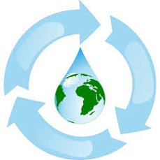
reuse | to use products more than once; ​  to find new uses for items
recycle | is a process to change used materials into new products; to prevent the waste of useful materials
eco-friendly | not harmful to the environment ​  (animals and plants) |     Would you rather cut down more trees to make paper, or recycle old paper into new instead?  
sustainable | not using up natural resources
durable | able to take wear, pressure, or damage; ​when something is hard-wearing
finite resources | is a natural resource that cannot be readily replaced
repair | restore (something damaged, faulty, or worn) to a good condition
environmental | relating to the natural world
reconstructed | build or form (something) again after it has been damaged or destroyed

