Knowledge Organiser Year 3 Summer 1 – How did Jesus show he was loving and caring?
Vocabulary |  | In this unit, we will consider how Jesus helped those in need over 2000 years ago. We will also learn about how Christians try to put Jesus’ Gospel into practice in 2020 and we will reflect on what it means to help the needy.  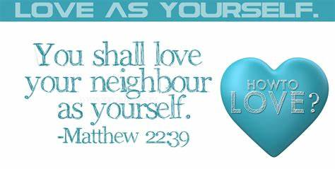  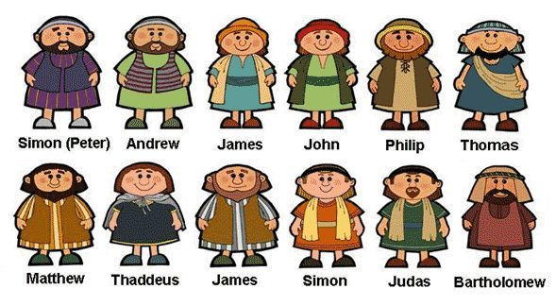
Clergy | A group of people who have the authority to lead religious services.
Preach | To deliver a sermon or lesson to a group of people, typically in a church.
Gospel | The record of the life of Jesus in the first four books of the New Testament (Matthew, Mark, Luke and John).
Jesus | Christians believe Jesus was the son of God, whose teachings were used as the basis of Christianity.
Church | A public building for Christian worship. The names vicar, priest and rector are all used to give names to the people who lead worship in church.
Bible | The holy book on which Jewish (Old Testament) and Christian religions are based.
Disciple | A follower of Jesus. Jesus had twelve specials friends, known as disciples, who learnt important lessons from Jesus and then taught others.
Beliefs | Something someone accepts as true or real; a firmly held opinion.
Faith | Trusting in something or someone.
Compassion | To recognise the suffering of others and take ation to help.
Leprosy | In the Bible, leprosy was a visible infection of the skin. There was no cure for the disease, which left a person disfigured, with the loss of fingers, toes and eventually limbs (arms/legs). People with leprosy were alienated from their communities and were made homeless. They had to find shelter outside of the towns and villages.
Refugee | A person who has been forced to leave their country in order to escape war, persecution, or natural disaster.

