Year 3 Summer 1 Parts of a Plant – Knowledge Organiser
VOCABULARY |  | 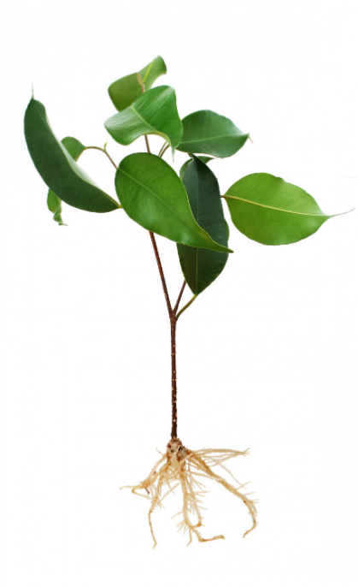 |  | Leaves  Leaves have one main function:  - Absorb light energy from the Sun to produce food using water from the soil and air. | Soil and nutrients
variable | something that can be controlled, changed or measured in a fair test. |  |  |  | 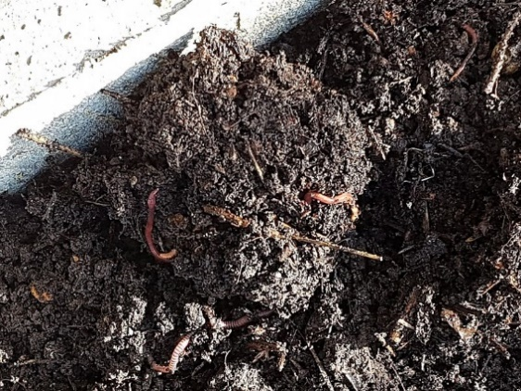  Plants need nutrients to grow and stay healthy. They get their nutrients from the soil. Nutrients get into the soil from:  - animal waste (poo)  - dead plants and animals which decay, and so their nutrients return to the soil  - synthetic chemical fertilisers.    I make my own food from air and water using sunlight energy … but I also need nutrients from the soil to keep me healthy.
survive | to stay alive. |  |  | Stem  The stem has 2 main functions:  - Support for the plant  - Transport of water and nutrients from the roots to the rest of the plant.
thrive | to grow or develop well.
nutrients | substances that help plants and animals to grow and stay healthy.
humus | the part of the soil that consists of dead plants that have begun to decay.
fertiliser | a natural or synthetic substance that contains nutrients to help plants grow. |  |  | Roots  The roots have 2 main functions:  - Anchor the plant to the ground  - Take up water and nutrients from the soil.
natural | found in nature (not synthetic).
synthetic | made by people (not found in nature).
synthetic | made by people (not found in nature). | Words you can use to describe an unhealthy plant
overcrowding | where too many things are living in one place for them to thrive. | dry  wilting  shriveled  withered  distressed  yellowing | 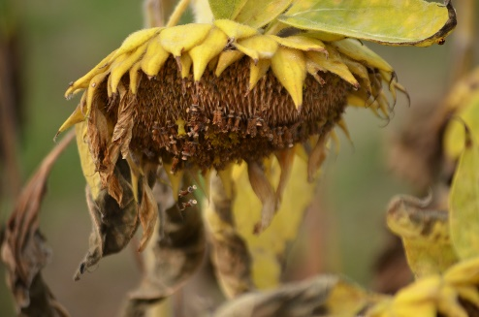
anchor (verb) | to secure firmly in position. | dry  wilting  shriveled  withered  distressed  yellowing
support | to hold something up. | dry  wilting  shriveled  withered  distressed  yellowing
transport | to move something from one place to another. | dry  wilting  shriveled  withered  distressed  yellowing

