Anglo - Saxons – Knowledge Organiser Year 3 Summer 1
Timeline
Vocabulary |  | How was Anglo-Saxon Britain ruled? |  | 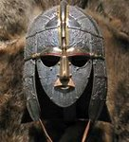  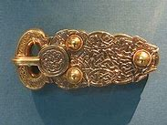  Anglo-Saxons Kings  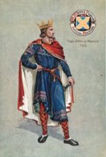  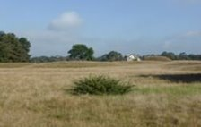  King Offa of Mercia from 757 AD to 796 AD.  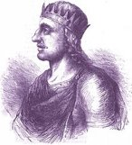  King Egbert of Wessex  802 AD to 839 AD  In May 1939, archaeologists in Sutton Hoo, Suffolk, made a fantastic discovery! As they dug away at a burial mound, they began to discover the outline of an enormous ship.  They had found a ship grave, but...there was no body!​ In the centre of the ship, they found a burial room, which was full of treasure, including jewellery, weapons, armour, cups and spoons and bits of clothes!  ​  https://www.britishmuseum.org/learn/schools/ages-7-11/ancient-britain/classroom-resource-sutton-hoo
Scots | People who come from the country of Scotland.  ​
Climate | The weather conditions that are typical of the place. | The Anglo-Saxons divided the parts of Britain they ruled over into 7 kingdoms and were also known as the Heptarchy. The table below, explains the meaning of the names they gave to them. These names are still used today and are part of the Anglo-Saxon legacy.
Defend | To protect from an attack.
Slaves | Someone who is the property of another person and has to work for that person. | 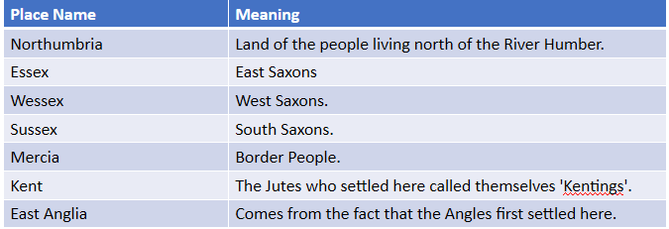
Kingdom | A country whose ruler is a king or queen.
Rule | A person or group that rules a country, controls it.
Dyke | A long wall made out of earth, by digging and piling it up.​
Saint | People who live such holy lives that they are prayed to after they have died.
Pagan | The Christian name for people who worshipped different gods.
Burial mound | A structure made of earth that people used to build over graves in ancient times | Why did the Anglo-Saxons invade Britain?
Artefact | An object that is made by a human being, especially one that is historically or culturally interesting | 1, More land for farming.  2. The Saxon homelands were flooded.  3. Better climate in Britain.  4. Crops at home were failing so there was not enough food.  5. Britain was easy to invade now the Romans had gone. | 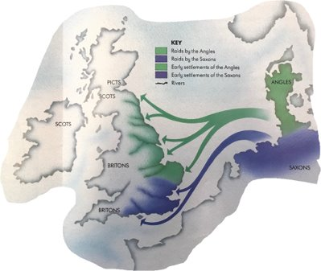
Sceptre | An ornamental rod that a king or queen carries on special occasions as a symbol of their power.
Culture | The 'way of life' for groups of people, meaning the way they do things.

