Friction and Magnets – Knowledge Organiser
VOCABULARY |  | Forces  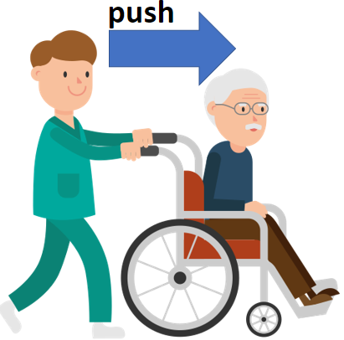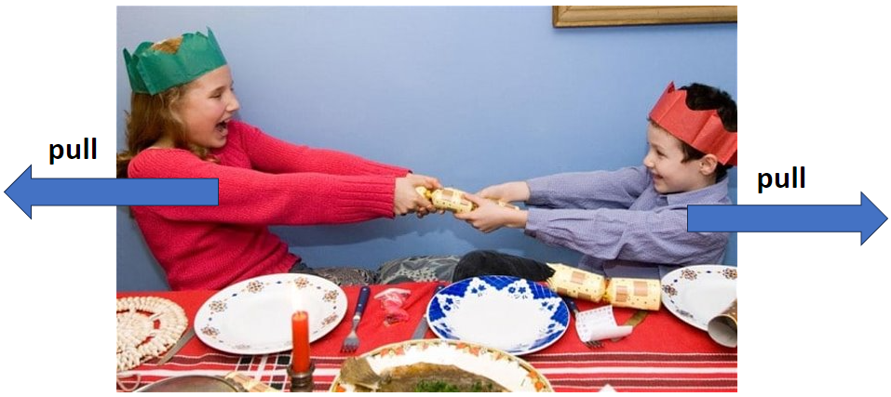  Friction  less friction more friction  - +    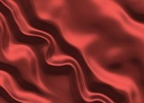  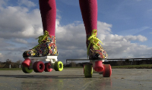  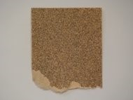    Magnetism  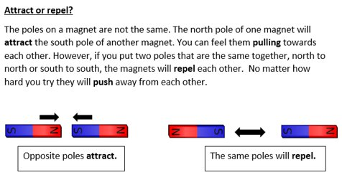
force | the pulling or pushing effect that causes something to move.
push | a force that tends to move things away.
pull | a force that tends to move things towards you.
twist | a turning movement caused by pushing or pulling in a circular direction.
friction | a force between two moving surfaces that are touching. Friction slows things down.
magnet | an object which attracts magnetic metals (such as iron).
magnetism | an invisible force which causes magnets to attract other magnetic materials.
poles | the opposite ends of a magnet (north pole and south pole).
attract | to pull (or be pulled) towards a magnet.
repel | to push (or be pushed) away from a magnet.
magnetic | a property of a material that makes it attracted to a magnet.

