Year 3 Knowledge Organiser spring 2 Festivals: Ramadan / Easter / Passover
Ramadan (Islam) | Ramadan is the ninth month of the Islamic calendar, observed by Muslims worldwide as a month of fasting, prayer, reflection and community. During the month of Ramadan, the Qur’an was first revealed to the Prophet Muhammad. Muslims try to give up their bad habits and become better Muslims by praying more or reading the Qur’an. | 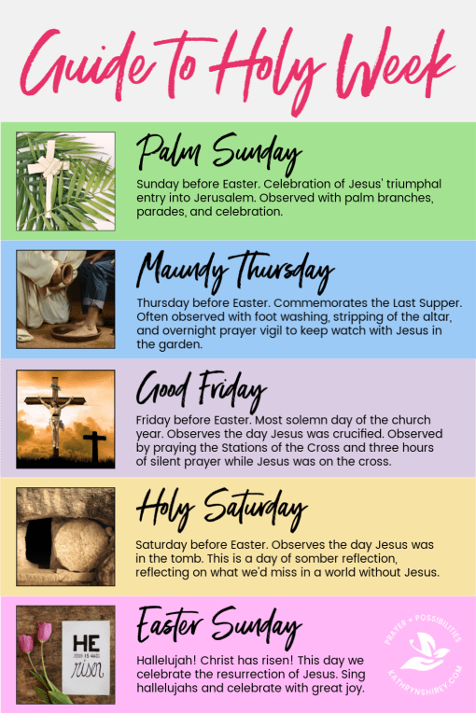  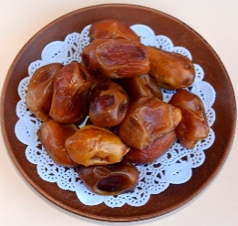  After the sun sets at  the end of each day,  most Muslims break  their fast with water  and dates.  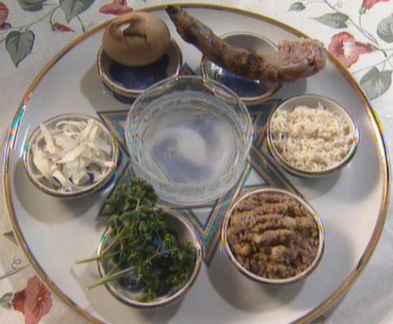  The Passover Seder is a ritual feast that marks the beginning of the  Jewish holiday of Passover.
Qur’an (Islam) | The sacred book of Islam.
Allah (Islam) | The Arabic word referring to the God of Islam.
Prophet Muhammad (Islam) | The founder of Islam.
Sawm (Islam) | The duty to fast during the month of Ramadan. To stop eating and drinking (including water) during daylight hours. One of the five pillars of Islam.
Suhoor (Islam) | The meal before sunrise.
Iftar (Islam) | The meal after sunset.
Zakat (Islam) | The duty to give to charity to the poor, usually money. One of the five pillars Islam.
Moses (Judaism) | A Prophet from the Old Testament who led the Jews out of Egypt.
Pharaoh (Judaism) | A political and religious leader in Ancient Egypt.
Passover (Judaism) | A major Jewish holiday, one of the most widely celebrated. It commemorates the Israelites’ departure from Ancient Egypt.
Pesach (Judaism) | Passover in Hebrew. Hebrew is spoken by many Jewish people.
Seder (Judaism) | The ritual feast that marks the beginning of Passover.
Easter (Christianity) | The celebration of the death and resurrection of Jesus Christ.
Holy Week (Christianity) | The events of the seven days before Easter Sunday.
Joy | A happy, lively emotion.
Despair | An emotion. A complete loss of hope.
Hope | Being optimistic and feeling that good things will happen.
Symbol | Something that represents something else.

