Rocks, Soils and Fossils – Knowledge Organiser Year 3 Spring 1
Vocabulary |  |  | How are rocks formed?
  Granite | 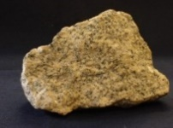 | Igneous
  Limestone | 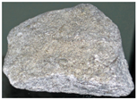 | Sedimentary
  Chalk | 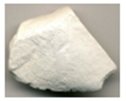 | Sedimentary
  Sandstone | 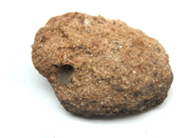 | Sedimentary
  Slate | 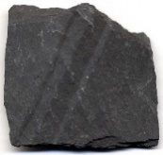 | Metamorphic
  Marble | 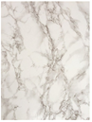 | Metamorphic
  permeable | A property of a material that  allows water to pass through.
  impermeable | A property of a material that prevents water from passing through.
geologist | A scientist who studies the surface of the Earth, especially rocks. |  | Rocks are classified by the process in which they are formed.  Igneous Rocks are formed from magma or lava once it has cooled.  Sedimentary Rocks are rocks formed from layers of sediment which are then crushed under the pressure of yet more layers.  Metamorphic Rocks are rocks formed when one type of rock is changed into another type by pressure and heat.
molten | Melted; in liquid form.
magma | Molten rock stored below the Earth’s surface.
lava | Molten rock once it has reached the Earth’s surface.
minerals | Metals or other substances found in nature, especially in rocks.
erosion | The gradual destruction and removal of rock or soil by rivers, the sea, or the weather.
sediment | Small solid ‘bits’ of material, especially soil and pieces of rock, that have been carried along by water, ice or wind and then left (deposited) somewhere. |  | What is soil?
sediment |  |  | Soil is made from tiny particles of rocks, organic material (rotting plants and animals), air and water. Living organisms, including worms and micro-organisms, live in the soil and help to keep it healthy.
fossils | The remains or imprints of animals or plants that died millions of years ago and been preserved in rock.
micro-organism  or microbe | A tiny living thing which you can only see if you use a microscope. |  | Clay soil is usually sticky and has few air gaps, which means water cannot drain through this soil easily.
saturated | Soaked; containing the maximum amount of water possible. |  | Chalky soil is usually light-coloured, stony and allows water to drain quickly.
organic | Substances produced by or found in living things. |  | Sandy soil is usually pale-coloured with large, grainy particles which means water drains through easily.

