Year 3 Knowledge Organiser spring 1 Hinduism Part 1: What do the different deities represent to Hindus?
VOCABULARY |  | 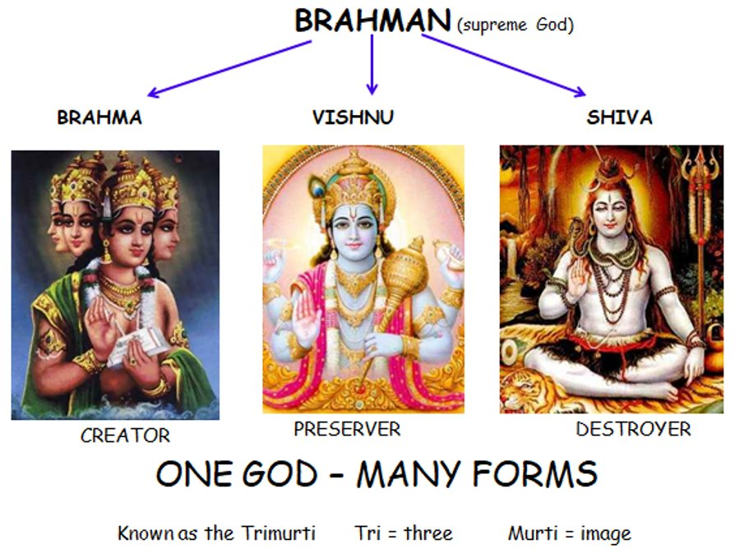  Ganesh Krishna  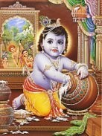  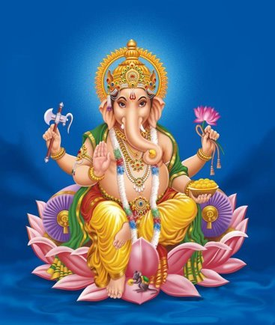
Hinduism | One of the world’s oldest religions – more than 4,000 years old.
Hindu | Followers of the religion of Hinduism. Many Hindus live in India and other Asian countries, like Nepal and Indonesia. But there are also a lot of Hindus who live in Europe, North America and Africa.
Brahman | The one God in Hinduism.
Murti | A sacred image/statue of a deity or person in Indian culture.
Trimurti | Three main Hindu deities – Brahma, Vishnu, and Shiva
Mandir | An Indian word for temple, where many Hindus worship.
Shrine | A place that has a holy statue or image of a Hindu deity which is used for prayer.
Monotheism | One God is worshipped
Polytheism | Many Gods are worshipped (Hinduism)
Mandir | A place where Hindus worship which is also called a temple.
Creation | Making something new
Universe | Everything that exists including the Earth and living things and all the stars and planets.
Destiny | What is intended for you in the future
Lotus flower | 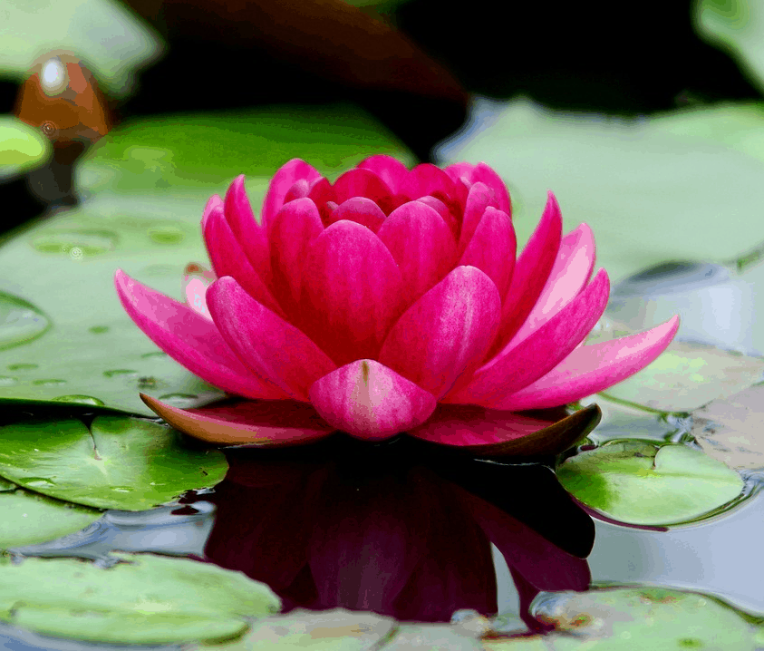  A flower that floats on water

