The Romans – Knowledge Organiser Year 3 Spring 1
Timeline
Vocabulary |  | 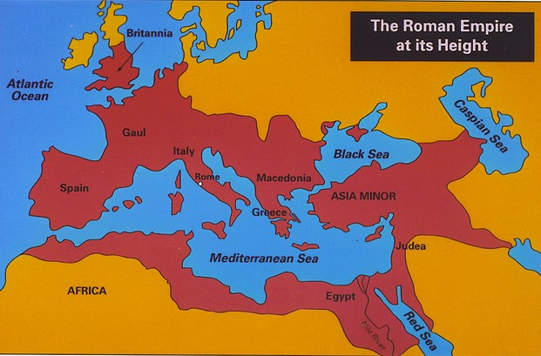  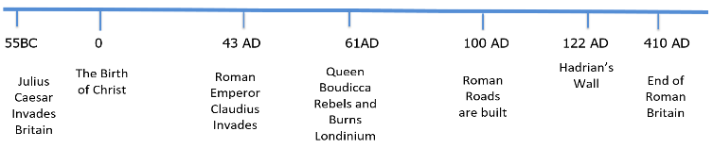  The Roman Empire | Important People
Invade | to enter a place by force. |  | Julius Ceasar | Ordered the invasion of Britain and failed.
Empire | a group of countries ruled by the government or ruler of one particular country. |  | Boudicca | Celtic Queen of East Anglia who revolted against Rome.
Conquer | to take complete control of a place or people. |  | Emperor Claudius | Emperor who ordered the invasion and conquest of Britain and succeeded.
Civilians | anyone who is not a member of the armed forces. |  | The Roman Invasion
Barbarian | a person who lived outside the Roman Empire, seen by the Romans as violent. |  | - In 55 B.C. Julius Caesar invaded Britain with two Roman legions. The Romans fought several battles against different Celtic tribes before returning to Gaul (France).  - In 54 B.C. Julius Caesar returned to Britain with a much larger army. He crossed the English Channel with five Roman legions. Again they fought against the Celtic tribesmen and demonstrated their strength and power. Julius Caesar agreed to leave Britain, but only if the tribes agreed to make a tribute (payment) to Rome.  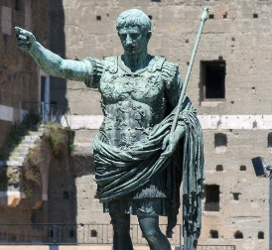  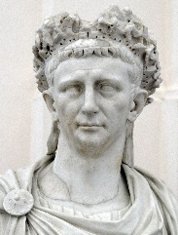  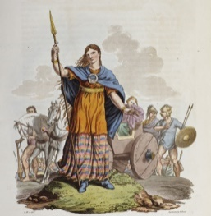  - In 43 A.D. Emperor Claudius launched a third and final invasion of Britain. A large battle was fought between the Romans and the Celtic tribes. The Romans emerged victorious, but it took many years to gain control of Britain, as many tribes (such as the Iceni led by Boudicca) continued to fight against Roman rule.
Revolt | to take violent action against a ruler.
Emperor | a man who rules an empire or is the head of state in an empire.
Legion | a large group of soldier who form one section of an army. | 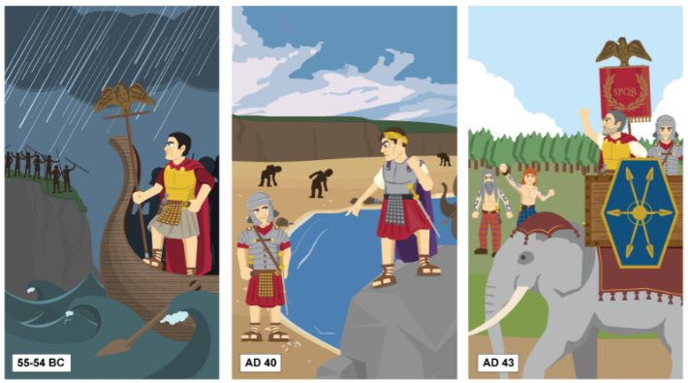
Conflict | a disagreement or argument.
Villa | a fairly large house.
Did you know?
- The calendar we use today is based on the Roman Calendar, and some of our months are names after Roman gods or rulers.
- The Romans were famous for their amazing feasts!
- The Romans didn’t have soap. Instead they covered their bodies with oil and scraped it off with a curved metal toil called a strigill.
The Romans conquer Britain
Even though The Romans were outnumbered by Boudicca’s warriors, they were better trained and had better armour. Both side clashed in a fierce battle, but the Romans won.

