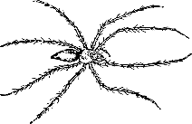
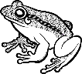
NUTRITION, SKELETONS and MUSCLES – Knowledge Organiser Year 3 Autumn 2
Vocabulary |  | Bones in the Human Body | Muscles
nutrition | The ‘goodness’ in the food we eat. Helps us to stay alive and grow | 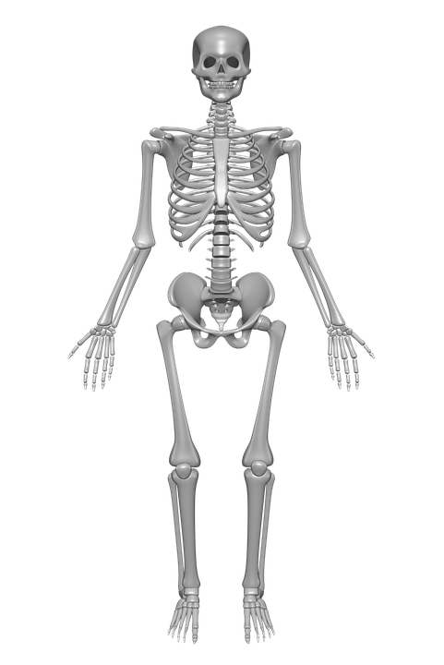  Knee cap  pelvis  ribs  skull  Spine | 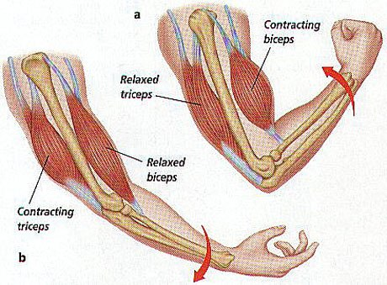  Muscles help us to move. When a muscle contracts,  the muscle shortens and pulls on the bone it is  attached to. When the muscle relaxes the muscle  goes back to its normal size and the bone moves back  again. Muscles usually work in pairs: as one muscle in  the pair contracts, the other one relaxes.
function | The use or job of something
skeleton | A framework of bones in a human or animal’s body
protection | Keeping something safe
support | Holding something up
joints | The places where two or more bones fit together
muscle | Parts of the body that pull bones around our joints to help us to move
contract | To become smaller or shorter
relax | To stop working and rest
exoskeleton | Means ‘outside’ skeleton – a hard covering  that supports and protects the bodies of some  invertebrates
Nutrition |  |  | Vertebrates | Invertebrates
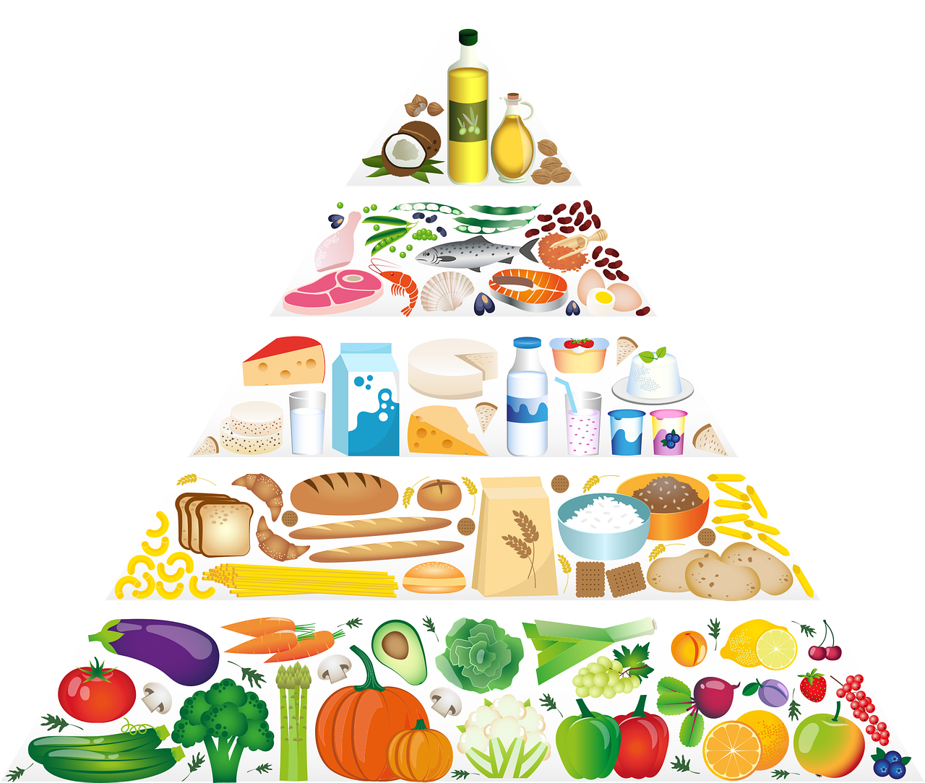  Nutrition is the ‘goodness’ in the food that we eat and is needed by the body to stay alive and  grow. Animals, including humans, cannot make their own food so they need to get all their  nutrition from the food they eat.  - It is important that animals have a ‘balanced diet’ so they can stay healthy. This  means they get the right amount of different types of food.  - A food pyramid shows how much we need of the different types of food. The smaller the section of the pyramid, the less food we need of that type.  For example, we only need a small amount of fats and sugars (at the top of  the pyramid) but we need a large amount of fruit and vegetables (at the  bottom of the pyramid). |  |  | 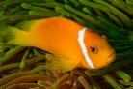  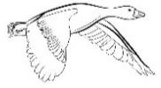  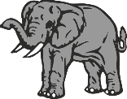  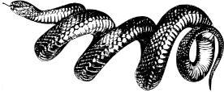  Animals with a  backbone | 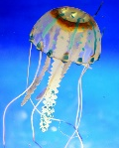  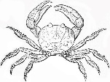  Animals with no backbone

