Christmas: A festival of light and love – Knowledge Organiser Year 3 Autumn 2
VOCABULARY |  | 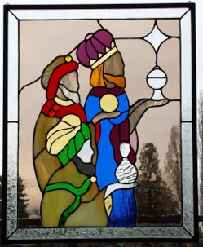  William Holman Hunt’s painting ‘Light of the World’.    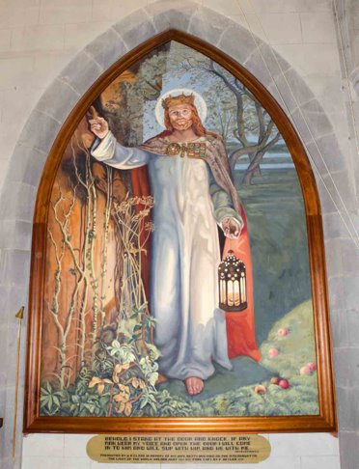    An advent wreath has four candles around the outside which symbolise the light of God, coming into the world through the birth of his son, Jesus. Christians refer to Jesus as ‘the light of the world’.  The four outer candles represent hope, peace, joy and love. The central candle represents Jesus. The greenery around the ring represents hope of newness and of eternal life.
Light of the world | Christians believe that Jesus is their guide
Diwali | Hindu festival of light
significance | Something really important
halo | A circle of light which Christians believe represents the light of God
advent | It means ‘coming’ and the period before Christmas which celebrates the birth of Jesus
preparation | Getting ready to do something in an organised way
advent wreath | The advent wreath symbolises the preparation for Christmas
stained-glass window | A window made of coloured glass often showing religious pictures and usually seen in churches

