Natural Disasters - Pompeii – Knowledge Organiser Year 3 Spring 2
Vocabulary |  | 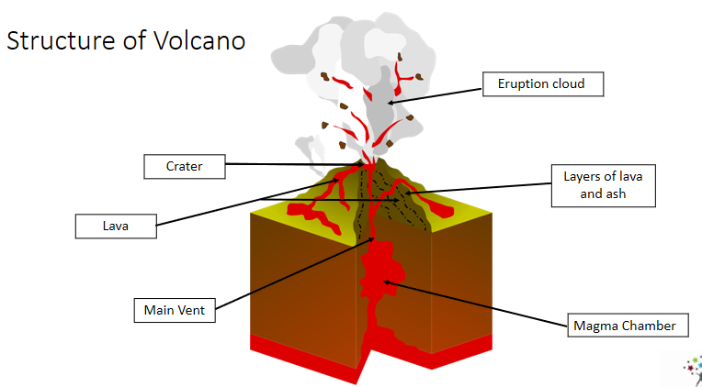  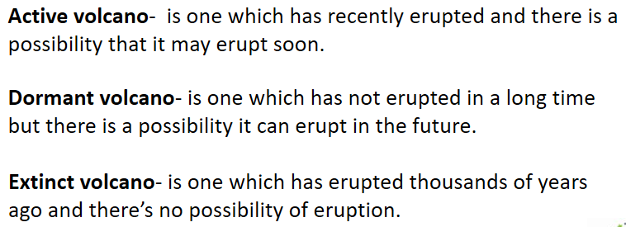  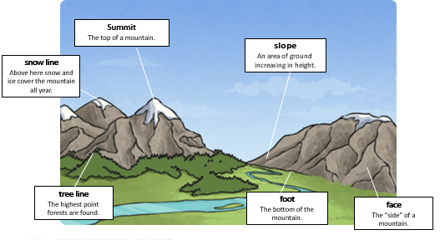  Mountains | How the Earth is structured
Mountains | A very high area of land with steep sides. |  | 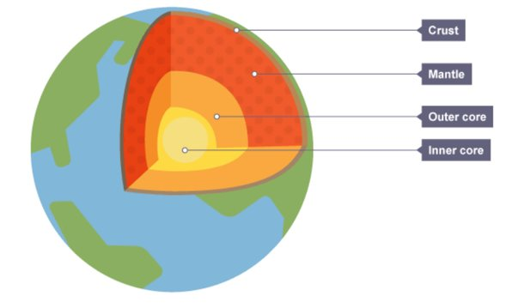  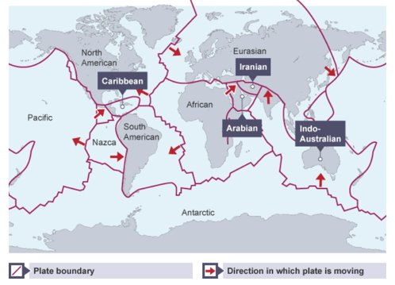  The surface of the Earth is made up of tectonic plates.  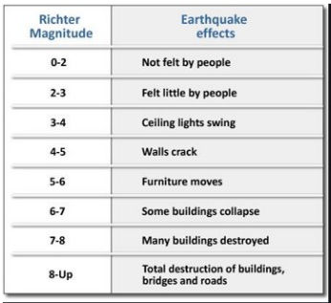  Earthquakes  Earthquakes are the sudden violent shaking of the ground. They are measured on a Richter Scale.
Tectonic plate | Tectonic plates are large plates of rock that make up the Earth's crust.
Volcano | A mountain from which hot melted rock, gas, steam, and ash from inside the Earth sometimes burst.
Molten Rock | Rock that has been melted.
Lava | Molten rock that oozes or flows above the earth's surface.
Ring of Fire | A belt like region, surrounding the Pacific Ocean, where most of the World’s volcanoes can be found and earthquakes happen.
Magma | Molten rock that oozes or flows beneath the earth's surface.
Preserved | To take action to save something from damage.
Cast | A model that has been made by pouring a liquid into something, so that when it hardens it has the same shape.

