Light and Shadows – Knowledge Organiser Year 3 Autumn 1
VOCABULARY |  | 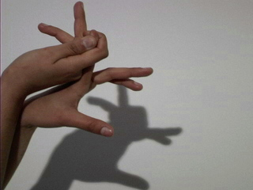 |  | Shiny or Dull?
source | the origin [beginning] of something or where it comes from. |  |  | A shiny surface reflects light well.  It does not absorb light well.  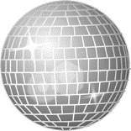  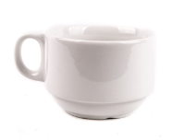  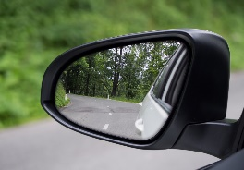  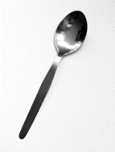  A dull surface absorbs light well.  It does not reflect light well.  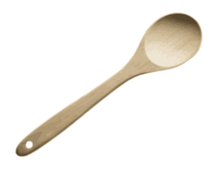  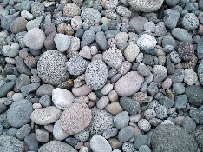  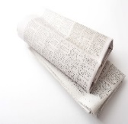  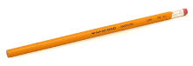
absorb | to ‘take in’ or ‘soak up’.
reflect | to ‘bounce’ light back from a surface.
reflective | a word to describe a surface that reflects or ‘bounces’ back light.
reflection | the image seen when light reflects off a mirror into our eyes.
shadow | a darkened area formed when an object blocks the light shining on it.
opaque | a word to describe a material which lets no light pass through and so is impossible to see through.
transparent | a word to describe a material which lets all the light pass through and so can be seen through clearly. | Light Sources
transparent |  | Natural | Man-made
translucent | a word to describe a material which lets some of the light pass through and so can be seen through but not clearly. | 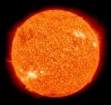  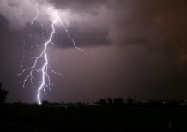  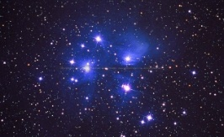  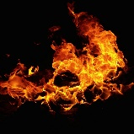 | 

