Knowledge Organiser Year 3 Autumn 1 – What does the Creation story teach Christians about God?
VOCABULARY |  | 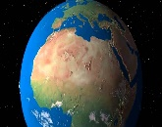  Christians believe that God created the  Universe | Harvest
  The Seven Days of Creation
  Day 1 | - light was created | 
  Day 2 | - the sky was created | 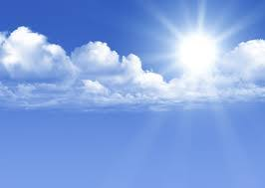
  Day 3 | - dry land, seas, plants and trees were created | 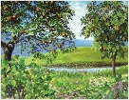
  Day 4 | - the Sun, Moon and stars were created to give light to the world | 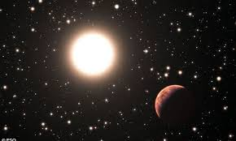
  Day 5 | - creatures that live in the sea and creatures that fly were created | 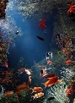
  Day 6 | - animals that live on the land and finally humans, made in the image of God were created | 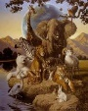
  Day 7 | God finished his work of creation and rested, making the seventh day a special holy day | 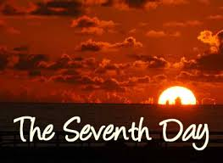
Creation | Something that someone has made for the first time. |  | - Harvest is a Christian Festival.  - It happens every year in the Autumn.  - It is a time where Christians say thank you for the harvest.  - This can be by singing songs, decorating churches and binging gifts to share.  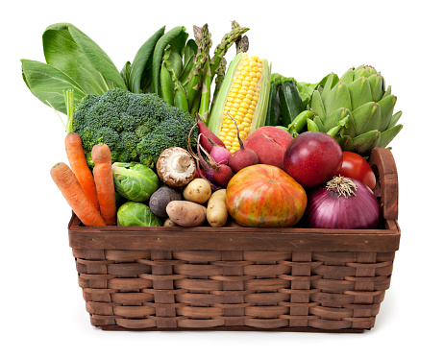
Creator | Used as a name to describe God as the maker of the universe.
Harvest | A time of year when the crops are gathered for food
Temptation | Something you want to have or do,  even though you know you shouldn’t.
Genesis | A book or part of the Bible which talks about creation.
Activist | A person who campaigns to bring about change for the better
Creation | Something that someone has made for the first time
Steward | A caretaker of the world
Environmentalist | A person who cares for the environment.
Disobey | Go against (dis- meaning not)

