The Stone Age to the Iron Age – Knowledge Organiser Year 3 Autumn 1
Timeline

Stone Age Bronze Age Iron Age The birth of Christ Victoria becomes Queen Queen Elizabeth is crowned Today

Vocabulary |  | 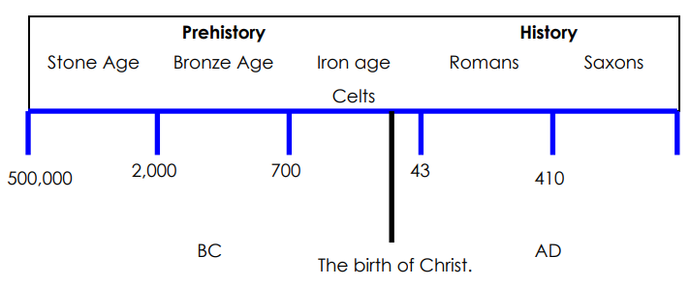 |  |  | Settlement
Prehistory | The period of time in the past before people could write |  |  |  | 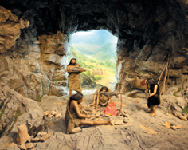  Early Stone Age people did not have homes but travelled to follow the food. They took shelter in caves or made tents using animal skins.  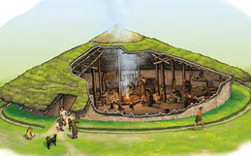  By the Bronze Age, people were living in small settlements that were made up of their family members.  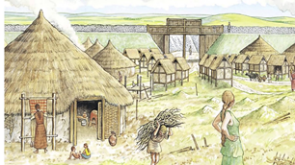  The Celts lived in much larger settlements built on the top of hills. These were known as hill forts and gave the community protection from other tribes.
Hunter-gatherer | Groups of people who get food by hunting, fishing and foraging rather than farming
Archaeologists | Someone who studies the buildings, graves, tools and other objects of people who lived in the past.
Nomad | A member of group of people who travel from place to place rather than living in one place all the time | BC and AD  BC means Before Christ.  A date such as 3000BC means 3000 years before the year 1 AD (there was no year zero)  AD – means Anno Domini in Latin which stands for ‘in the year of our lord’. A date such as 2018 AD means 2018 years after Jesus is supposed to have been born. |  | Important Time Periods Stone Age – When the first humans began to live in Europe. They used stone tools to cut meat, scrape skins and cut up plants.
Tribes | A group of people that live together for protection
Celt | A person belonging to a group of people from western Europe who came to live in ancient Britain before the Romans. |  |  | Bronze Age - In this era, metals were used to make hunting tools. Humans also began to farmland.
Hill fort | A settlement surrounded by a wall, on top of a hill
Warrior | A fighter or soldier, especially one in former times who was very brave and experience in fighting |  |  | Iron Age - Humans now used iron to make tools, and farmed land instead of hunting. They  lived in communities.
Era | A length of time covering many years | Did you know...?
Fortified | Something that has been strengthened in order to protect it from attack | Humans discovered how to make fire in the Early Stone Age.  The first Stone Age people followed herds of animals and could walk from Britain to Europe without getting their feet wet. At this time, Britain was joined to Europe and there was no sea in between! | The first writing and counting systems were developed during the bronze age.  The first coins were used in the Bronze Age. Coins were needed as some people were able to make things that others wanted and could not make for themselves.
Marketplace | A small area in a town or city where good are bought and sold, often outdoors
Plough | Is a large farming tool with sharp blades which is pulled across the soil to turn it over, usually before seeds are planted

