LIFE CYCLES, REPRODUCTION and STAGES IN HUMAN GROWTH – Knowledge Organiser Year 5 Summer 2
Vocabulary |  | Stages in Human Growth | Changes in Puberty | Asexual Reproduction in Plants
adolescence | The time between the start of puberty and  adulthood | 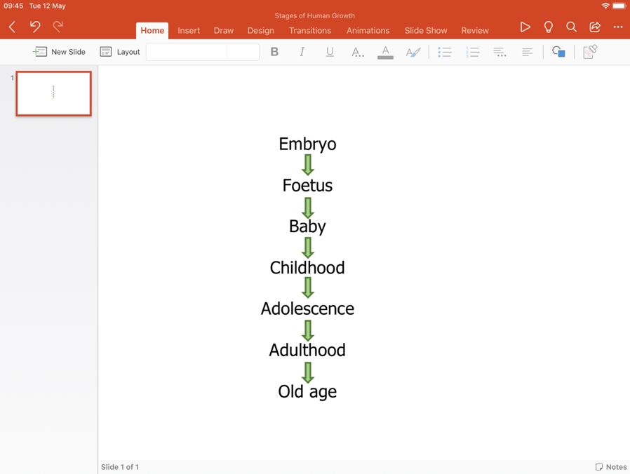 | - There are emotional and physical changes  - Girls usually begin puberty earlier than boys  - Reproductive organs mature  - Children have a growth spurt  - There is an increase in sweat production  - Growth of body hair  - Muscle growth  - In girls, widening of hips and breast development | Plants can reproduce asexually through their stems, roots, and leaves. Asexual reproduction requires one parent and produces plants which are identical to the parent. Examples include:  bulbs  runners  tubers  rhizomes  Asexual reproduction can also be artificial e.g., taking cuttings.
puberty | The stage when a person’s reproductive system matures and a child’s body changes into an adult’s
embryo | Animal in the uterus (womb) in its earliest stage of development
foetus | Animal in the uterus (womb) in its later stages of  development
sexual  reproduction | The process of creating a new living thing by the joining of pollen and egg (plants) or sperm and egg (animals)
asexual  reproduction | The process of creating a new living thing by  one parent without the need for sexual reproduction
fertilisation | The joining of male and female parts (e.g. egg and pollen or egg and sperm) | Sexual Reproduction in Plants
anther | Part of the stamen that produces pollen | 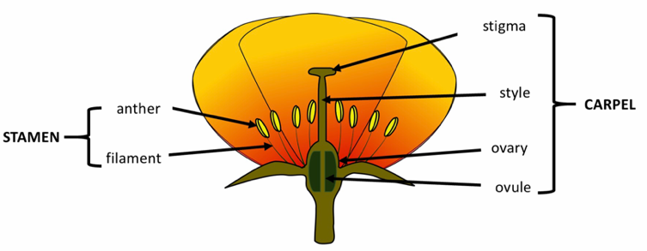  Flowers have male and female parts. Sexual reproduction involves the transfer of pollen from the male anther to the female stigma during pollination. The pollen goes down into the ovary and joins with the egg (ovule) where fertilisation occurs and a seed is formed. This requires two parents and produces plants which are similar but not identical to the parents.
filament | A slender stalk that supports the anther
stigma | Part of the carpel that receives the pollen
style | Part of the carpel. Connects the stigma to the ovary to allow pollen to pass to the ovules
ovary | In flowers, the part of the carpel that contains the ovules
ovule | The scientific word for an egg. Joins with the pollen to make a seed | Animal Life Cycles  Male Parts
metamorphosis | The change from a young animal to an adult in two or more distinct stages
   | Mammal | Amphibian  Female Parts | Insect (Complete metamorphosis) | Insect (Incomplete metamorphosis) | Bird
  Lays egg(s) | x | √ | √ | √ | √
  Number of stages in life cycle | 7 | 5 | 4 | 3 | 4
  The young look like the adult | Yes | No | No | Yes | Yes
nymph | Young insect which can look similar to the adult but does not have wings
pupa | Young insect in a non-feeding stage which is usually surrounded by a cocoon or case
larva | Young insect (or another invertebrate) which looks very different to the adult (e.g. caterpillar)

