Buddhism – Knowledge Organiser Year 5 Summer 2
Vocabulary |  | The Origins of Buddhism | The Eightfold Path
Buddhism | A philosophy followed in Asia mainly, founded 2500 years ago.  Buddhism is one of the top 6 faiths in the UK. | Over 2,500 years ago in India Prince Siddhartha Gautama was born into a life of luxury and wealth. For the first years of his life he was protected from the suffering in the world.  At the age of 29 Siddhartha left the palace and for the first time in his life he saw an old man, a sick person and a grieving family. Siddhartha was upset by the suffering he had witnessed.  He decided that he would leave his life of luxury and seek an answer to the suffering.  Siddartha met a holy man who had no material possessions and was content with life. He joined a group of holy men who taught him to meditate. During this time he went without food shelter or any kind of comfort. Siddartha felt that this way of life also led to suffering and was not the answer he was looking for.  After leaving the group of holy men he found a fig tree and sat under it for days meditating, searching for the answer to happiness.  On the 49th day he achieved enlightenment – achieved a state of complete peace, awareness and wisdom. From this point he became known as the Buddha, the enlightened one.  From then on he spent his time travelling throughout India and spreading his teachings.  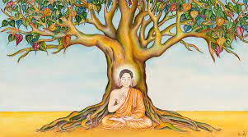 | In Buddhism, the Noble Eightfold Path is the path to the end of suffering. It is the fourth part of the Four Noble Truths.  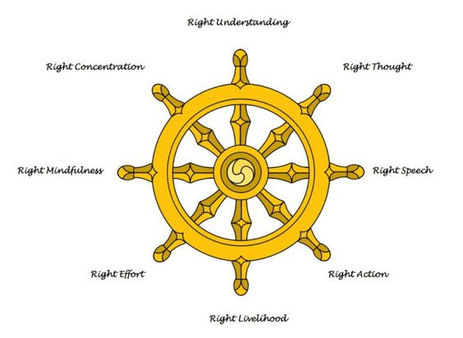
Buddhist | A follower of Buddhism.
Buddha | The Enlightened One
Enlightenment | When you understand something.
Nirvana | Once Buddhists achieve a state of complete peace, awareness and wisdom, they reach Nirvana.
Meditation | A practice for calming one's mind and body. Meditation is different from worship.
Suffering | To experience pain or loss. In Buddhism, suffering doesn't always relate to pain but it can be linked to emotions people feel – for example jealousy and greed.
Dharma | Teachings of Buddha to show the right way to behave in Buddhism. It is represented by a wheel with eight pathways.
Dharma |  |  | The Four Noble Truths  1.Suffering happens all the time because people always want more or something better than what we have (greed).  2.Because we don’t have what we want we suffer and feel upset.  3.If we accept what we have and stop wanting more we will become happy.  4.Follow the Noble Eightfold Path.
dukkha | All human life involves suffering. This is known as 'dukkha'. This leads to suffering as we cannot get everything we want.
The Eightfold Path | Rules that Buddhists try to live by.
Tipitaka | Translated literally means 'triple basket'.  They are the ancient collections of Buddhist scriptures.
Vihara | A type of Buddhist temple which has living accommodation for monks and nuns.

