Forces – Knowledge Organiser Year 5 Summer 1
Vocabulary |  | 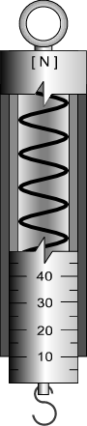  Force meter |  | Water resistance  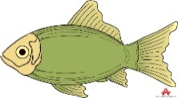  thrust  Water resistance  Water resistance
gravity | The force attracting two objects towards each other. It keeps the Moon and planets in orbit.
newton (N) | Unit of measurement of forces.
Force meter  (newton meter) | An instrument with a spring for measuring forces.
mass | A measure of how much of something there is. Measured in g and kg.
weight | The force experienced when gravity pulls an object downwards. | Friction  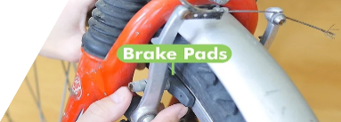  Useful | Friction  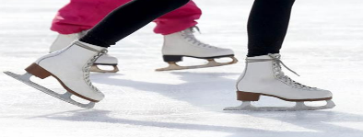  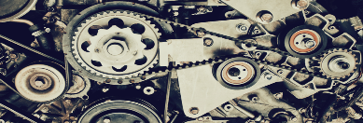  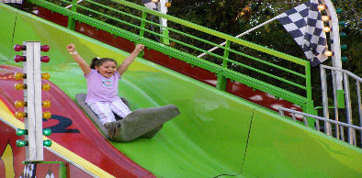  Nuisance | Lever  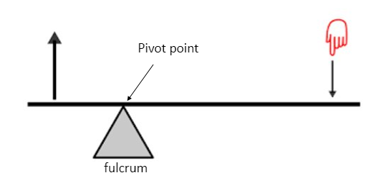
friction | The force between two surfaces that causes moving objects to slow down. Creates heat.
lubrication | The addition of a fluid between moving surfaces to reduce friction.
air resistance | A type of friction caused by air pushing against a moving object.
water resistance | A type of friction caused by water pushing against a moving object. |  |  | Pulley  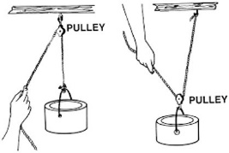
streamlined | Being smooth, narrow or pointed in shape to reduce air or water resistance.
upthrust | Upwards force in a fluid. In water, this helps to keep swimmers and boats afloat.
load | An object with mass that is lifted (by a machine).
machine | Device that makes work easier (e.g., by reducing the effort needed to lift a load). | 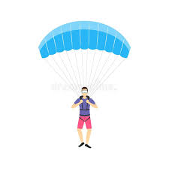  Air resistance  gravity  Air resistance |  | Gears  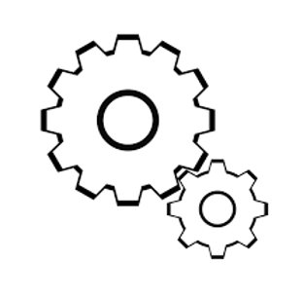
lever | Simple machine made of a long, rigid arm or bar that pivots around a fulcrum to lift a load.
pulley | Simple machine made of a grooved wheel on a  fixed axle, which guides a rope or cable to lift a load.
gears | Simple machines made of toothed wheels slotting together. When one turns so does another. If the gears are different sizes, they can increase the power of a turning force.

