What can we learn from stories from stories shared by Christians, Jews and Muslims? – Knowledge Organiser Year 5 Summer 1
VOCABULARY |  | 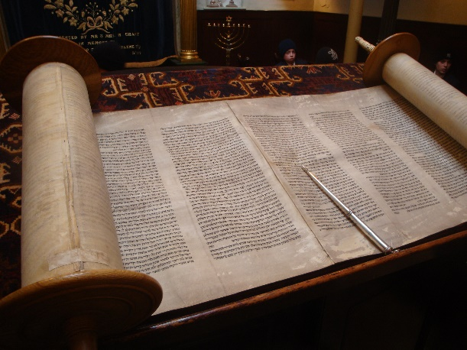  The Torah  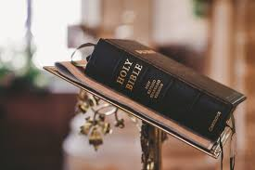  The Bible  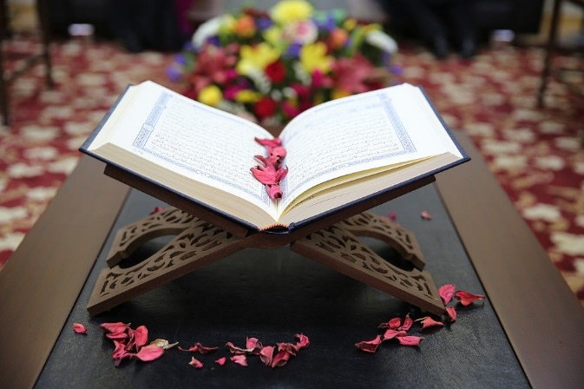  The Qu’ran
The Bible | The Christian holy book
The Torah | The Jewish Holy Book. Every Synagogue has a Torah that is handwritten on scrolls. No one is allowed to touch the parchment. It is written in a language called Hebrew.
The Qu’ran | The holy book for Muslims. The Qu’ran according to Islam is the very word of Allah, revealed through Angel Jibril to the Prophet Muhammad.
Sacred | Something that is sacred is believed to be holy and to have a special connection with God.
Holy | A characteristic of God as well as a lifestyle for people to emulate.
Tending | Looking after
Drought | A long period of low rainfall, leading to a shortage of water.
Mighty | Possessing great and impressive power or strength.
Governor | Someone appointed to make decisions for a town or area.
Intended | Planned

