Walter Tull (World War One) – Knowledge Organiser Year 5 Summer 1
Timeline
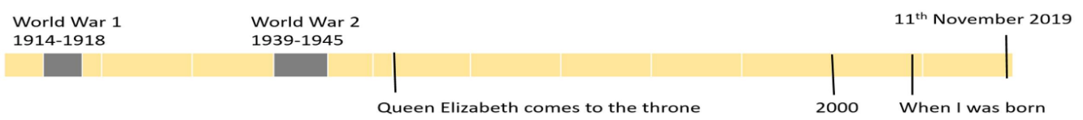

Vocabulary |  | 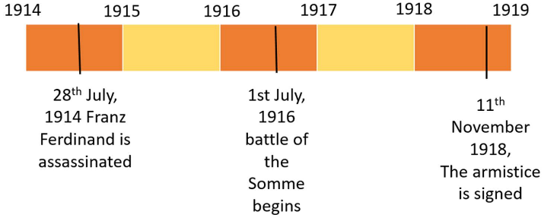 | Important People
Assassination | When somebody is killed as a political act. |  | Archduke Franz Ferdinand | 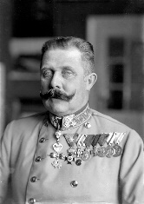  Prince of Austria-Hungary and heir to the throne. Assassinated by a Bosnian man called Gavrilo Princip in 1914.
The Allied Powers (or Triple Entente) | Britain, France, Russia, Italy and the United States. |  | Archduke Franz Ferdinand
The Central Powers | Germany, Austria-Hungary, Ottoman Empire and Bulgaria. |  | Archduke Franz Ferdinand
Offensive | An attacking military campaign. |  | Walter Tull | 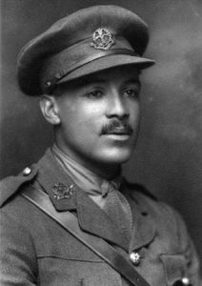  Northampton Town footballer who joined the British army and served in two Football Battalions.
Conquer | To overcome and take control of a place or people by military force. | The Alliance System  Many countries had made alliances with one other. They agreed to protect each other. If one was attacked, the others would defend them. The war was fought between:  · Central Powers: Germany, Austria-Hungary and their allies.  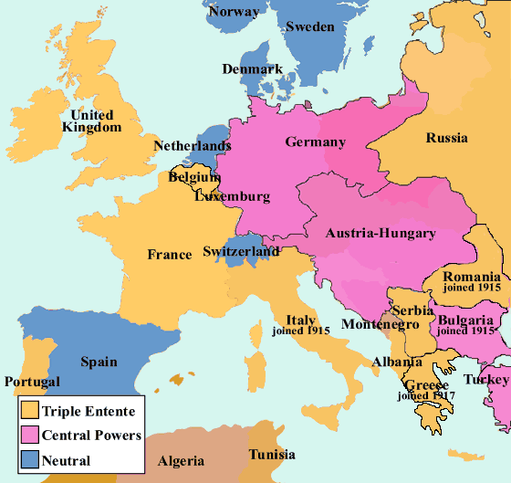  · The Triple Entente: Great Britain, France and Russia. | Walter Tull
Pals Battalion | Special large groups of troops in the British Army which consisted of men from the same local areas. |  | Walter Tull
Armistice | An agreement by both sides to stop fighting during a war. |  | 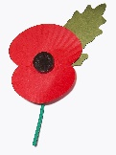  Remembrance Day  Every year on 11 November, people in the UK stop for a short moment of reflection. Poppies, which grew on the barren fields of World War One, are used to remember soldiers who died.
Empire | A number of individual nations that are all controlled by the government or ruler of one particular country.
Enlist | To join the armed forces. |  | Trench Warfare
No Man’s Land | The empty area of land between two trenches. |  | Many battles were fought using trench warfare.  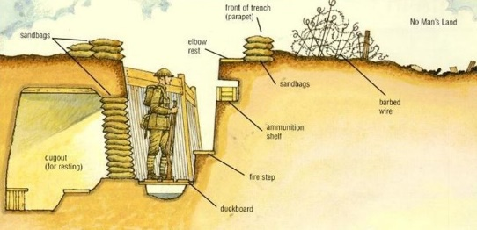  Long ditches were dug in the ground. Soldiers lived in the trenches and sometimes climbed out to attack. A famous example of trench war was the Battle of the Somme which started in July 1916.
Artillery | Large, powerful guns which are transported on wheels and used by an army.
Treaty | A formal agreement between two or more countries.
The Great War | The name used for World War One at the time. Also called World War 1, First World War, WW1 and the War to End All Wars.

