PROPERTIES AND CHANGES OF MATERIALS 2 – Knowledge Organiser Year 5 Spring 2

Vocabulary |  | Examples of Irreversible Changes
irreversible | A change that can only go one way. Also known as a non-reversible or permanent change. | 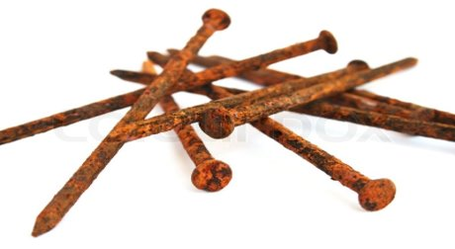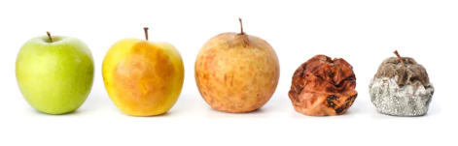
products | The new materials made as a result of an irreversible change.
combustion | The scientific word for burning (in the presence of oxygen).
rusting | The irreversible change which causes the weakening (corrosion) of iron and steel in the presence of oxygen and water.
decomposition | The scientific word for rotting of organic (once- living) materials.
separation technique | A method for sorting and separating out the different parts of a mixture.
magnetic | Being attracted to a magnet. (Antonym: non- magnetic).
sieve | Equipment with a mesh for separating out solids of different sizes. | Features of Irreversible Changes | Distillation of sea water to collect pure water
filtration (filtering) | A separation technique for separating out an insoluble solid from a liquid. In the classroom or lab this usually consists of a funnel and a cone of filter paper. | - They only go in one direction (in other words, you cannot get back what you started with).  - They display evidence that a change is taking place (e.g., flames, explosion, smell, change of colour etc).  - New products are always formed. | 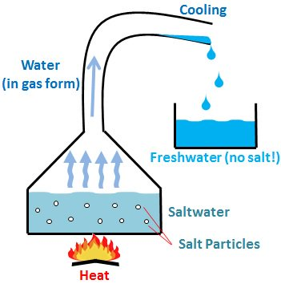
residue | The solid left behind in the filter following filtration.
filtrate | The liquid that passes through the filter during filtration.
distillation | The technique used to separate a liquid from a solution using evaporation and then condensation.
saline (adjective) | Salty.

