How is Christianity expressed through the arts? Knowledge Organiser Year 5 spring 2
Vocabulary |  | 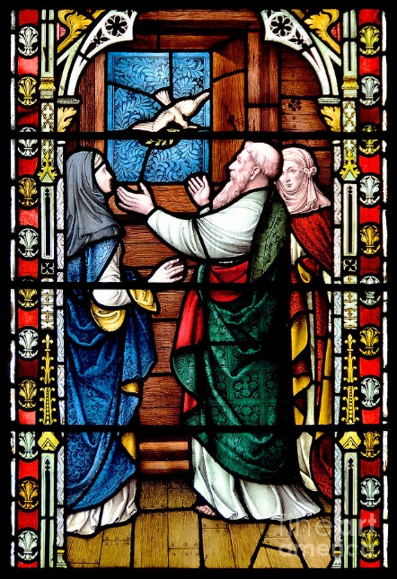  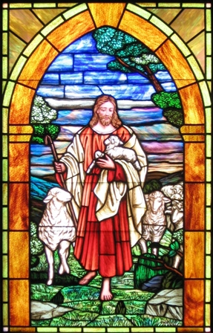  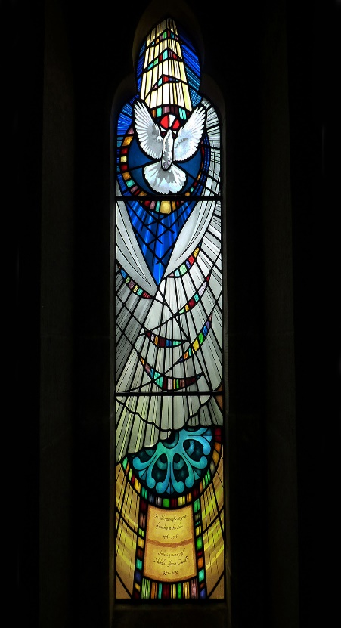  Stained-glass window  When churches were initially built, not many people could read and write. The church was a place where people went to learn as well as to worship. The stained-glass windows represented Bible scenes, which allowed the church to communicate Bible stories and Christian beliefs to all people. The stained-glass windows brought the stories to life. The different colours of the stained-glass windows in churches represented different things.
Spiritual | Being spiritual is about your own self, and how you fit the world together, other people, the planet and God (if you believe in God).
Psalms | Poems and songs in the Old Testament of the Bible which express feelings.
Grace | In Christianity and other religions, grace is the kindness God shows to people because he loves them.
Commitment | People do things because of their belief.
Symbols | A mark or sign with a special meaning.
Symbolism | The use of symbols to stand for something.

