Shakespeare in the time of the Tudors Knowledge Organiser Year 5 Spring 1
Timeline
Stone Age
Iron Age
Bronze Age
The Romans
The Birth of Christ
The Victorians
Britain Modern
Tudor times 1485-1603
Vocabulary |  | 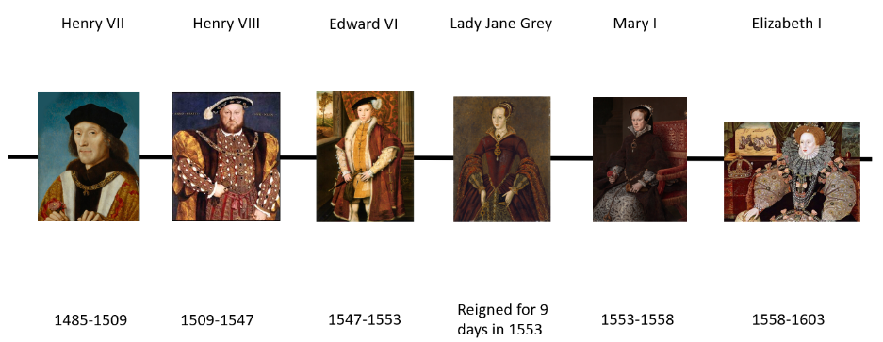 |  | The Globe theatre- then and now
Era | A period of time in history. An era often begins or ends with an important event. |  |  | 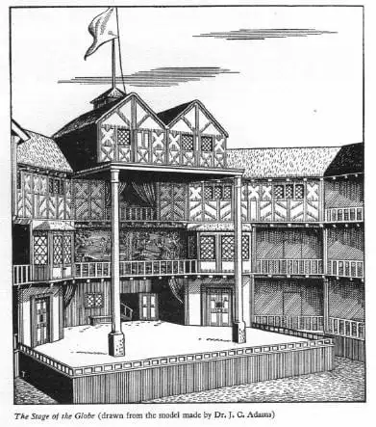  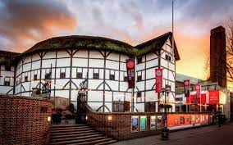
Catholic | A Catholic is a Christian with different beliefs to Protestant Christians. Catholic Christianity was the main religion in Europe in the time of the Tudors. | 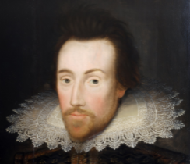  William Shakespeare  1564- 1616 | William Shakespeare was an actor and playwright who lived and worked in London and Stratford upon Avon during the reign of Elizabeth I.
Protestant | A protestant is a Christian with different religious beliefs to Catholic Christians. Throughout history these two religious groups have had many conflicts.
Line of succession | The order in which individuals are expected to succeed one another as the monarch |  | William was born around 23rd April 1564 and died on 23rd April 1616.
Heir | A person who inherits and continues the work of the person before them |  | During his lifetime, William wrote 37 plays, many of which were performed at the Globe Theatre in London.
Contemporary | Belonging the present time
Descendant | Someone’s descendants are the people in later generations who are related to them | Shakespeare’s family | Did you know...?
Descendant |  | Shakespeare’s family | Shakespeare’s granddaughter Elizabeth lived in Abington Manor (now Abington Museum) with her husband. She is buried in the church next door to the manor.
Legacy | Something which is the direct result of a person a time or an event and continues to exist after it. | Shakespeare was married to Anne Hathaway and had 3 children: Susanna, Hamnet and Judith.

