PROPERTIES AND CHANGES OF MATERIALS – Knowledge Organiser Year 5 Spring 1
Vocabulary |  | The Particle Model
particle | Tiny building blocks which make up matter. | The Particle Model is used to explain the physical properties of solids, liquids and gases. It  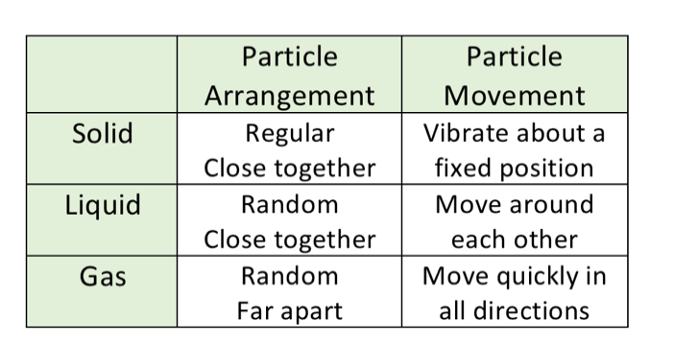  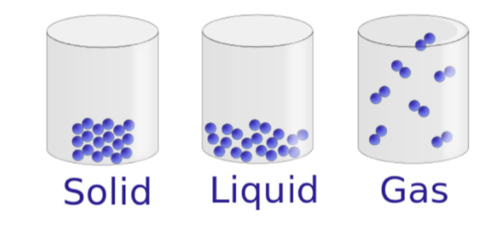  describes the arrangement and movement of particles in a substance.
bonds | The forces holding particles together.
transparency | The property of allowing light to pass through.
translucency | The property of allowing light to partially pass  through.
hardness | A measurement of how hard something is.
magnetism | Having the force that attracts to a magnet.
electrical conductivity | The ability to allow electricity to pass through.
thermal conductivity | The ability to allow heat to pass through.
substance | A solid, liquid or gas with particular properties. | Dissolving | Reversible Changes
mixture | A combination of substances which can be  separated. | 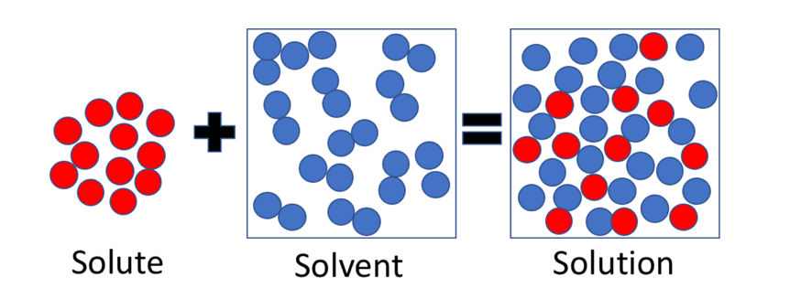  Salt + Water = Saltwater  Sugar + Tea = Sugary Tea | These are changes which can be  reversed or undone. Examples  include:  Melting  Freezing/solidification  Evaporation  Condensation  Mixing  Dissolving
dissolve | To mix with a liquid to form a solution.
soluble / insoluble | Can dissolve / Cannot dissolve.
solvent | A liquid that can dissolve other substances.
solution | A mixture where one substance is dissolved in a  liquid.
solubility | The measure of how soluble something is.
reversible | A change that can go both ways.

