Knowledge Organiser Year 5 Spring 2 – What is important to Jewish people?
Vocabulary |  | Jewish symbols
Jew | People who practice Judaism. | 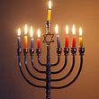  Menorah Candle used during Hanukkah  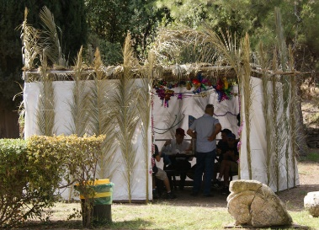  Sukkot shelter  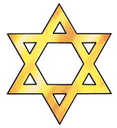  Star of David
Jewish | Belonging to the faith of Judaism.
Judaism | The monotheistic religion of the Jewish people.
Torah | The Jewish holy book.
Covenant | A promise made by God to humanity in which God promised to protect them if they kept His law and were faithful to Him.
Maccabees | A family of Jews who organised a rebellion against the Greek ruler Antiochus IV.
Hannukah | A festival that celebrates the victory of the Maccabees over the Greek ruler Antiochus IV.
Menorah | A special candle holder for seven or nine candles used during the festival of Hannukah.
Shamash | The servant candle used to light the other candles in the Menorah.
Dedication | A feeling of strong support for or loyalty towards someone or something.
Abrahamic | Faiths who recognize Abraham as their first prophet. The faiths of Judaism, Christianity and Islam.
Monotheistic | People who believe in one God. Followers of Abrahamic faiths only believe in one God.
Sukkot | A holiday of joy also known as the Feast of Tabernacles or the Feast of Foods. Time to remember the forty years in the desert before the Jewish people reached the promised land of Israel.
Sukkah | Huts or booths. Must have at least two walls and part of a third wall with a roof where you can still see parts of the sky. It reminds Jews that there is one source of security and protection and that is God.
Kosher | Foods which are prepared in accordance with Jewish law. The Torah specifies which foods should be eaten.

