EARTH and SPACE – Knowledge Organiser Year 5 Autumn 2
Vocabulary |  | Sequence of planets from the Sun | Movement of the Sun, Earth and Moon
universe | The whole of space and all the stars, planets and other form of matter and energy in it. | 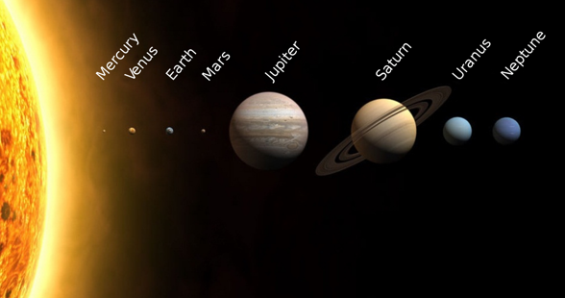  Mercury – the smallest planet (rock)  Venus – the brightest planet (rock)  Earth – the only planet on which life is known to exist  (rock)  Mars – known as the red planet (rock)  Jupiter – the largest planet (gas)  Saturn – known for its rings (gas)  Uranus – the coldest planet (gas)  Neptune – the furthest planet from the sun (gas)  ——————————————————————————-  Mnemonic to help remember the planets  My Very Easy Method Just Speeds Up Naming  (planets)  (Until recently the p in planets stood for Pluto but this is  now classified as a dwarf planet.) | - The Earth takes 24 hours (1 day) to rotate once on its axis.  - The Earth takes 365¼ days (1 year) to orbit the Sun.  - The Moon takes 28 days to orbit the Earth.  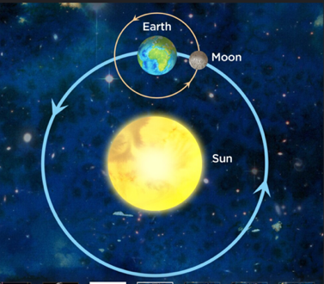  Day and Night  The Earth rotates anti-clockwise on its axis once every 24  hours.  At any one time, half of the Earth is in darkness (night-time)  and half is in light (daytime).  As the Earth rotates, it appears that the Sun moves across  the sky, with the Sun rising in the East and setting in the  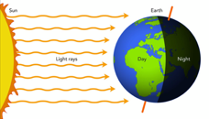  West, but it is the Earth which is moving not the Sun.
galaxy | The extremely large group of stars and planets to  which the Earth and solar system belong.
solar system | The Sun and all the objects that orbit it due to its  gravity.
planet | A large, round object in space that moves around  a star.
star | A large ball of burning gas in space.
satellite | A small object that orbits around a larger object in space. They can be natural or artificial.
Sun | The star at the centre of our solar system.
Earth | The fifth largest planet in our solar system and the only one thought to have people living on it.
Moon | A natural satellite of the Earth made of rock.
spherical | Has the shape of a sphere.
gravity | A force pulling two objects towards each other.
orbit | The curved path through which objects in space move around a planet or star.
rotate | To turn around a point or axis.
axis | An imaginary line around which an object rotates.
day | The time taken for a planet to rotate once on its axis (for Earth this is 24 hours).
year | The time taken for a planet to orbit the Sun (for  Earth this is 365¼ days).
lunar month | The time taken for the Moon to orbit the Earth (28 days).
horizon | The line at which the Earth’s surface and the sky  appear to meet.

