CHRISTIANITY: PEACE AT CHRISTMAS - Knowledge Organiser Year 5 Autumn 2
VOCABULARY |  | 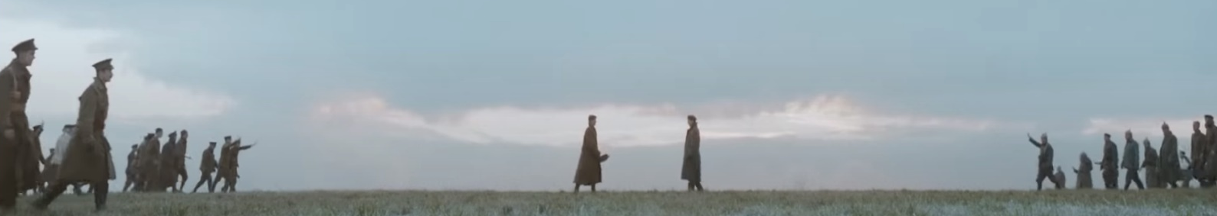  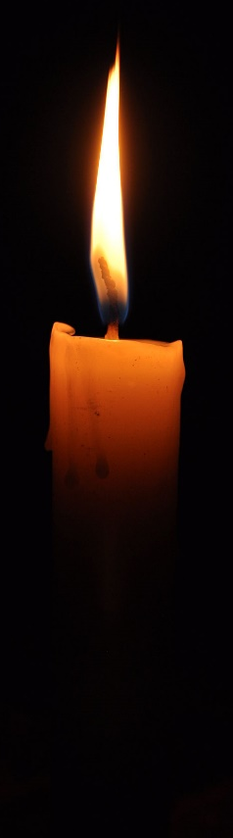    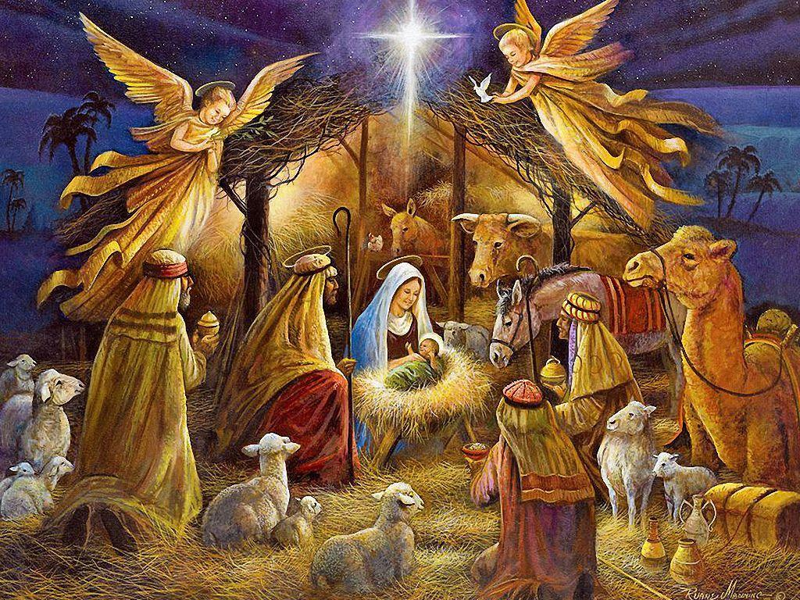  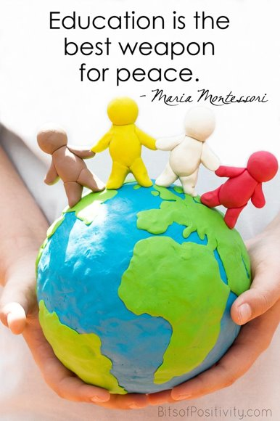
Peace | A time without fights or wars. This is external peace. When we feel harmony, quiet or calm, this is internal peace.
Foe | An enemy
Truce | An agreement which stops fighting or arguing where a conflict exists.
Refugee | A person who has been forced to leave their country in order to escape war, danger or natural disaster.
Conflict | A serious disagreement between people/countries which can lead to war.
Danger | The threat of something unpleasant happening which fills people with fear.

