North America from East to West – Knowledge Organiser Year 5 Autumn 2
 |  |  | 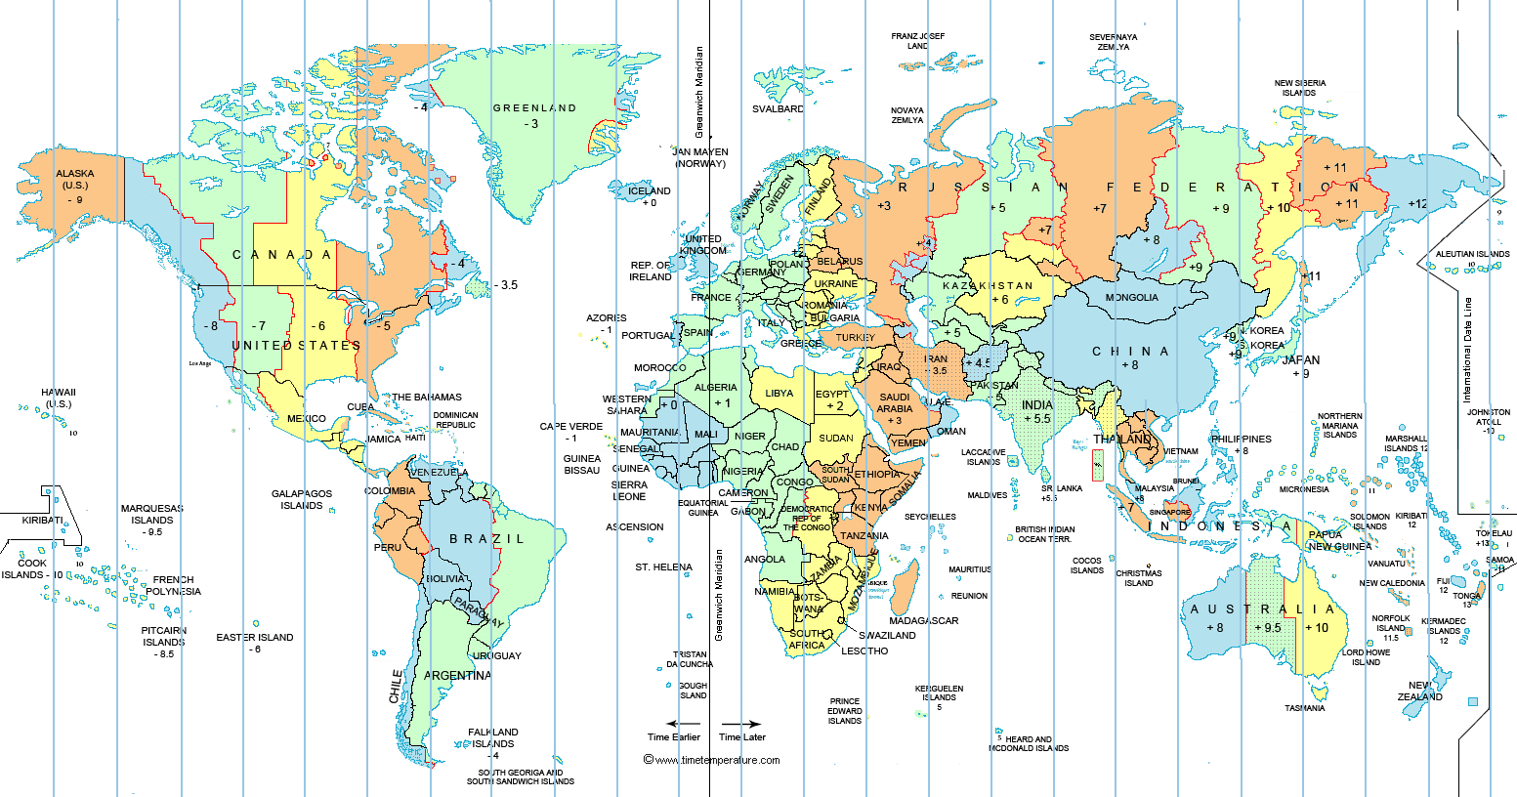  Map of World Time Zones |  | Key Knowledge
Region | An area of land that is part of a country and is not the capital city. |  |  |  | Northampton, England is in the region of the East Midlands in the United Kingdom.  Northampton, UK has a population of approximately 250,215.  Northampton, UK is located by the River Nene.  Northampton, Massachusetts is in the region of New England in North America.  Northampton, MA has a population of 28, 549.  Northampton, MA is located by the Connecticut River.
  Detailed Map of Massachusetts
  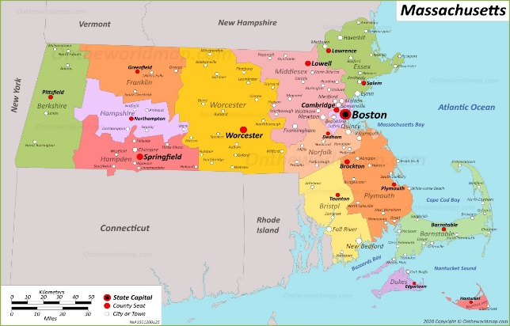
Time zones | Time zones give a specific area on the Earth a time of day, that is earlier or later than the neighboring time zones.
Biome | A large area of land that has a certain climate and certain types of living things.
Vegetation belt | Plant life that can be found in a certain area, according to its weather conditions.
Average | Is a typical amount of something.
Temperate | Used to describe a place which is never extremely hot or cold. |  | Time Zones  Greenwich Mean Time (GMT) is the standard time in the United Kingdom, which is used to calculate the time in the rest of the World.  Northampton, Massachusetts is 4 hours behind the time in the UK.
Suburban | Is a small area, which is part of a city or large town, but is outside its centre.
 |  | Northampton, UK |  | Northampton, MA
Wettest Month |  | December |  | June
Hottest Month |  | July |  | July
Coldest Month |  | January |  | January

