EARTH and SPACE – Knowledge Organiser Year 5 Autumn 1
Vocabulary |  | What is the Moon? | Movement of the Sun, Earth and Moon
Sun | The star at the centre of our solar system. | The Moon is a large ball of rock that orbits the Earth. It  is believed that the Moon was created 4.5 billion years  ago when a large planet-sized object collided with the  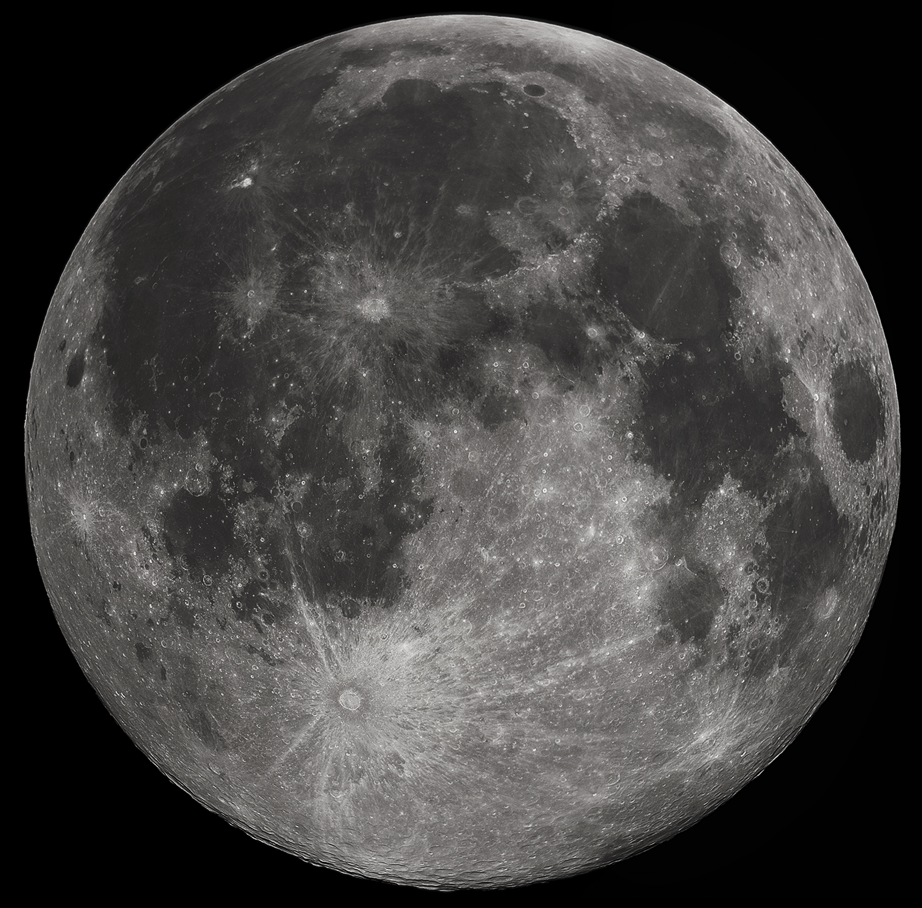  Earth.  The surface of the Moon is covered with craters. These  are the result of meteorites colliding with the Moon.  The impact of these collisions leaves a large dent in the  surface of the Moon known as a crater.  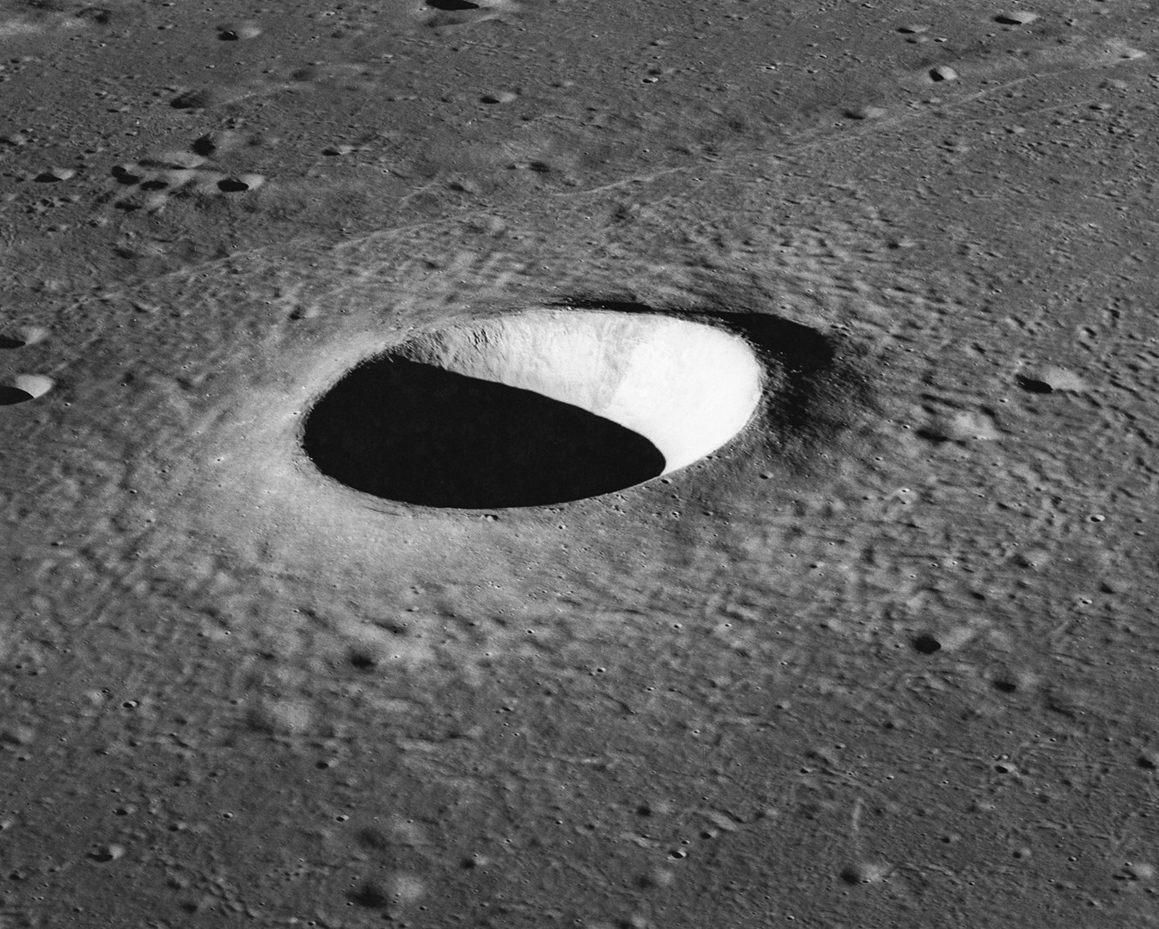  The Moon is the second brightest object in the sky after  the Sun but it doesn’t shine with its own light: it  reflects the light from the Sun. As the Moon orbits the  Earth, the Sun lights up different parts of its surface. We  see the part of the moon that is lit up by the Sun. | - The Earth takes 24 hours (1 day) to rotate once on its axis.  - The Earth takes 365 ¼ days (1 year) to orbit the Sun.  - The Moon takes 28 days to orbit the Earth.  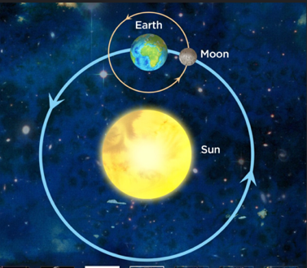  Day and Night  The Earth rotates anti-clockwise on its axis once every 24  hours.  At any one time, half of the Earth is in darkness (night-time)  and the other half is in light (daytime).  As the Earth rotates, it appears that the Sun moves across  the sky, with the Sun rising in the East and setting in the  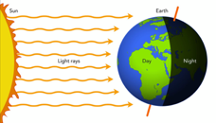  West; but it is the Earth which is moving, not the Sun.
solar | Relating to (‘to do with’) the Sun.
Earth | The fifth largest planet in our solar system and the  only one thought to have humans living on it.
Moon | A natural satellite of the Earth made of rock.
lunar | Relating to (‘to do with’) the Moon.
crater | A large dent/hole in the surface caused by something hitting it or by an explosion.
sphere | A 3D shape (the shape of a globe or football).
spherical | Having the shape of a sphere.
disc | A flat 2D circular shape.
circumnavigate | To completely travel around the globe (usually associated with sea travel).
gravity | A force pulling two objects towards each other.
orbit | The curved path through which objects in space move around a planet or star.
rotate | To turn around a point or axis.
axis | An imaginary line around which an object rotates.
day | The time taken for a planet to rotate once on its axis (for Earth this is 24 hours).
year | The time taken for a planet to orbit the Sun (for  Earth this is 365 ¼ days).
lunar month | The time taken for the Moon to orbit the Earth (28 days).
phase | The Moon’s apparent ‘shape’ created by the Sun lighting up different parts of the lunar surface.
horizon | The line at which the Earth’s surface and the sky  appear to meet.

