The Industrial Revolution – Knowledge Organiser Year 5 Autumn 1
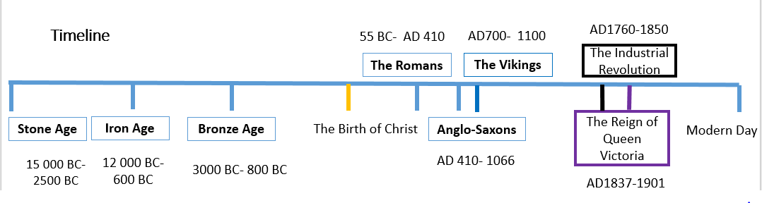
Vocabulary |  | Important People |  | Important Events
industrial | Related to industry, using machinery often in factories. | Queen  Victoria | Queen of the United Kingdom from 1837 to 1901. Came to the throne at age 18 and encouraged great domestic change and growth. She adopted the additional title of Empress of India on 1 May 1876. | Pre-Industrial Revolution | Roughly, 80% of the population lived in the countryside and farmed the land
Imperial | belonging or relating to an empire or the person/monarch or country that rules it | Queen  Victoria |  | First useful Steam Engine | Invented by  Thomas Newcomen in 1712.
revolution | A change in the way a country works, usually to a different political system or way of life. | James  Watt | He was known as the ‘Father of the Industrial Revolution’. He improved the steam engines so they could be smaller; use less coal and were used in factories throughout England. | Arkwright’s Spinning Frame | Patented in 1769 to stop others copying his invention. This spinning machine spins 96 strands of yarn at once.
famine | Where there is not enough food for a great number of people, causing illness and death. | Richard Arkwright | A British inventor and entrepreneur during the early Industrial Revolution. He was the first to develop factories, which could mass produce yarn for use in making textiles. | The Age of Steam | Born in Britain 1770-1914
merchant | A person whose job is to buy and sell products in large amounts, especially by trading with other countries. | George Stephenson | A British civil and mechanical engineer who was known as the "Father of Railways". | Perfected Steam Engine | By James Watt in 1778 now used throughout British industry
impact | A powerful effect that, especially something new, has on a situation or person (also the force or action of one object hitting another) | Isambard Kingdom Brunel | A British civil engineer considered one of the greatest figures in engineering history. He created groundbreaking designs and ingenious constructions. | Steam  Railway Engines | Running in Britain after 1825 Hugely, cutting journey times e.g. from Manchester it took 4 days and was reduced to 4 hours
technological | Relating to, or involving, technology | 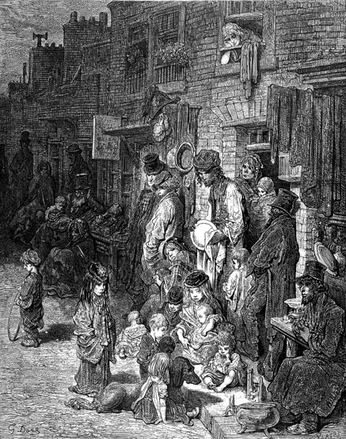 |  | Factory Act | In 1833, two hours of education a day compulsory for children working in factories.
Act of Parliament | Creates a new law or changes an existing law. |  |  | Queen  Victoria | Reigned as Queen of the United Kingdom from 1837 to 1901.
employee | A person employed by another for wages. |  |  | Queen  Victoria | Reigned as Queen of the United Kingdom from 1837 to 1901.
legislation | A group of laws (e.g. factory legislation). |  |  | Queen  Victoria | Reigned as Queen of the United Kingdom from 1837 to 1901.
industrialised | Where industries have been developed on a wide scale. |  |  | Elementary Education Act | In 1880, school attendance was made compulsory for children between the ages of 5 and 10
transformed | Where the appearance of something changes considerably. |  |  | 1901 Census | Britain’s population of was around 30 million.

