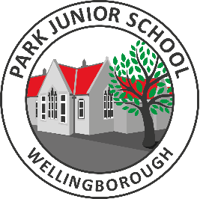
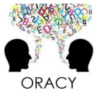
Ten ideas to support oracy

Discuss the meaning of vocabulary – after reading a text with your child or hearing different vocabulary, ensure you discuss what the vocabulary means.
Discuss a T.V. programme – talk about the themes of the programme. Ask them what they liked about it or what might happen in the next show.
Come up with a word of the day – encourage new vocabulary learnt to be used in your child’s writing or in a conversation they have that day.
Listen to different types of oracy – podcasts, poetry, radio shows, television programmes, educational videos, panel discussions, speech, job interviews, stand-up comedy or music.

Interview someone – encourage your child to interview a neighbour, a family member or a family friend. Come up with questions together and identify what they might learn from this experience.
Correct spoken English – if your child says “I’m gonna go to the shop.” Correct this with “I am going to the shop.”

Create a talk box – this is an exciting way to ensure conversations take place in your house. This could be an item that can be collected by your or your child. It can be as simple as a leaf, with the idea that your child talk in detail about how you came to have the leaf in your talk box.
Ask questions to develop answers – ‘why’ is such a powerful word to use with your child, it develops their sentences and thought processes as they have to explain further.
Play a game and discuss the rules – this can be as simple as a playing different board games and getting your child to explain the rules or getting your child to teach you a game.



