
Reading with your child
7-11 years
Why Read?
Sharing books and stories with your child is fun! It is a great way to build special memories and moments with your child and can easily become a favourite part of the day. It also helps children:
- Understand the world around them.
- Develop social and emotional skills.
- Improve at school in English, science, maths and other subjects.
- Build confidence and communication.
- Strengthen their bond with you and other family members.

A minimum of 15 minutes of reading per night/day is recommended.

‘Keep plenty of reading materials in your home: books, magazines, newspapers, and comic books. Children enjoy having a variety of reading materials!’

Reading with your child
Helping your child develop a love of reading can be a wonderful experience for a parent. It’s never too early to start enjoying books together. Reading to your child from an early age helps to give them the best possible start in life.


Ask questions when you are reading together. For example:
- Can you predict what is going to happen next? Can you find any evidence in the book that helped you make that prediction?
- Why did (the character) do that?
- What did the author mean by…?
- (Character name) must be feeling…? Are there any clues that help us know that?
Help your child analyse the book:
- What things would make everyone like this book?
- In what ways does the author make you feel as if you were there?
- What are some examples of good words?
- Do you know what this word means?

Great Book Ideas!
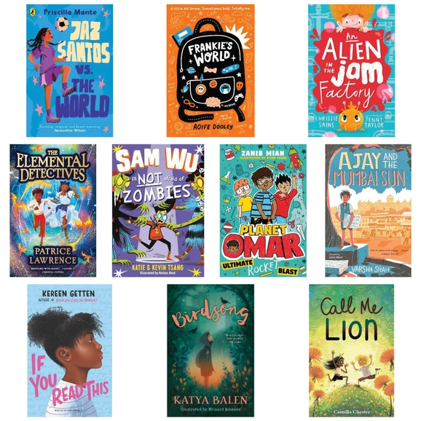


Top Tips!
Make reading a part of your family time.
Family time is so important! Here are some tips for integrating reading into our daily family activities:
- Read bedtime stories.
- Visit your local library.
- Read a recipe and cook together.
- Create a comfy reading space.
- Put your child in charge of reading the shopping list.
Find out what interests your child and aim to find reading material that will hood them into reading.
Don’t just limit your child to books. Expose them to other forms of reading material. For example, magazines, newspapers and online texts.
Discuss and explore rich vocabulary and make it a challenge to use them in conversation.
Encourage expression, fluency and tone to ensure your child is developing a confident reading voice.

